Communication objective
This annual report provides information about The Public Trustee’s financial and corporate performance for 2018–19. It has been prepared in accordance with the Financial Accountability
Act 2009.

The Public Trustee is committed to providing accessible services to Queenslanders from all culturally and linguistically diverse backgrounds. If you have difficulty in understanding this annual report, you can contact us on 1300 360 044 and we will arrange an interpreter to effectively communicate the report to you.
Copyright
© The Public Trustee of Queensland, September 2019. Published by The Public Trustee, 444 Queen Street, Brisbane QLD 4000, Australia.
Licence
This work is licensed under the Creative Commons CC BY 4.0 Australia Licence. In essence, you are free to copy and distribute this material in any format, as long as you attribute the work to the State of Queensland (The Public Trustee) and indicate if any changes have been made. To view a copy of this licence, visit https://creativecommons.org/licenses/by/4.0/.

ISSN 2205 – 7919
Attribution: The State of Queensland, The Public Trustee of Queensland
Disclaimer: While every care has been taken in preparing this publication, the State of Queensland accepts no responsibility for decisions or actions taken as a result of any data, information, statement or advice, expressed or implied, contained within. To the best of our knowledge, the content was correct at the time of publishing.
An electronic copy of The Public Trustee’s Annual Report 2018–19 is available online at www.pt.qld.gov.au. You can also contact us to request a copy by calling 1300 360 044 or emailing governance@pt.qld.gov.au
A number of annual reporting requirements are also addressed through publication of information on the Queensland Open Data website at data.qld.gov.au.

Contents
Communication objective ii
Contents iii
Letter of Compliance iv
Message from the CEO 1
Our 2018–19 highlights 3
Who we are 4
Where to find us 4
Our vision 5
Our purpose 5
Our legislation 6
Official Solicitor 7
Our 2018–19 achievements 9
Our strategic direction 12
The year ahead 13
Our strategic challenges and opportunities 15
Non–financial performance 16
Queensland Government objectives for the community 16
Community Service Obligations 17
Summary of our performance 18
Philanthropy 19
Financial performance 21
Public Trustee of Queensland Investment Fund – Growth Trust 24
Management and structure 25
Executive leadership 25
Senior internal management committees 29
Boards and committees with external membership 33
Public Sector Ethics 38
Public Sector Values 39
Governance – risk management and accountability 41
Governance and Risk Directorate 41
Risk management 44
External scrutiny 45
Internal audit 45
Information systems and recordkeeping 46
Our people 47
Workforce planning and performance 47
Workforce development 47
Early retirement, redundancy and retrenchment 48
Our offices 49
Outreach locations 50
Glossary 53
Acronyms 55
The Public Trustee of Queensland Financial Statements 56
Public Trustee of Queensland Growth Trust Financial Statements 103
Compliance Checklist 125

Letter of Compliance
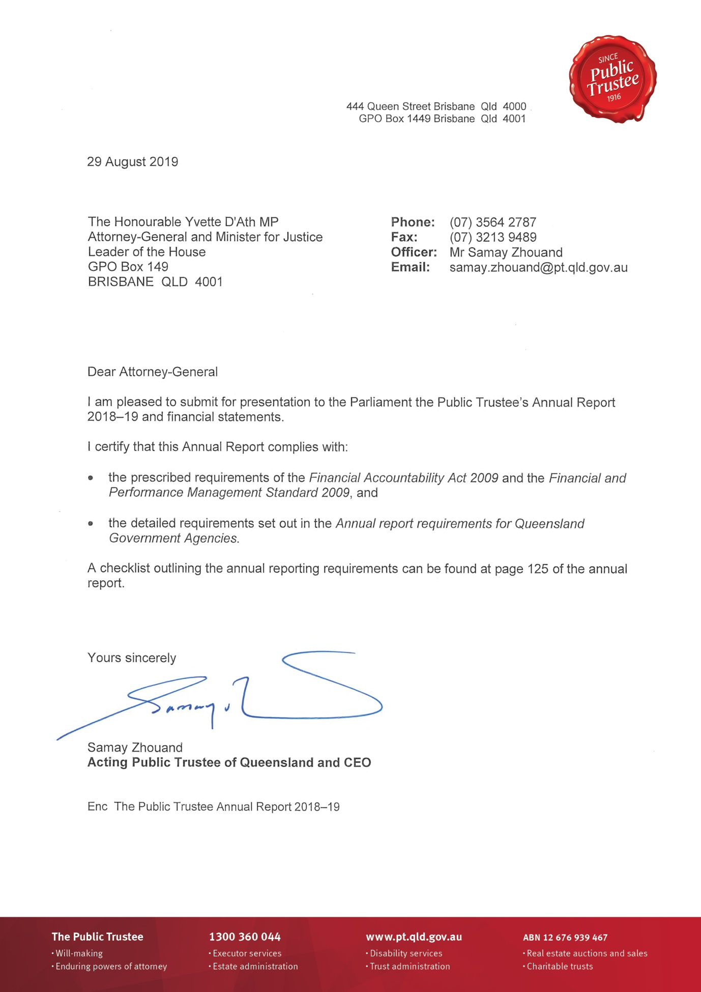

Message from the CEO
As Acting Public Trustee of Queensland and Chief Executive Officer of the Public Trustee, I am pleased to present the Annual Report 2018–19.
The Public Trustee provides independent trustee, estate and administration services to some of Queensland’s most vulnerable. The past year has seen the Public Trustee provide support to thousands of Queenslanders. Having recently joined the organisation, my first and ongoing impression of the Public Trustee is that its professional and forward facing staff demonstrate motivation and dedication in striving to serve the interests of their clients. This commitment to clients and the client experience they will receive is reflected in the Client Service Charter. Annual client surveys on deceased estate administration, financial management and will-making services continue to measure client satisfaction and identify opportunities for improvement. This year the surveys were extended to include trust administration clients.
The Public Trustee’s commitment to its clients is also reflected in the year’s achievements, which included:
- making 28,426 Wills at no cost to Queenslanders
- making 3684 enduring power of attorney (EPA) documents
- accepting 2135 new deceased estates for administration
- financial management for 9151 adults with impaired decision-making capacity
- acting as Financial Attorney under 258 EPAs
- managing 4467 trusts
- safeguarding over 1.1 million Wills in our atmospherically controlled Wills bunker
- providing almost $37.1 million in Community Service Obligations to the Queensland community, including Wills at no cost, rebated fees for financial administration for adults with impaired decision-making capacity, and community education
- facilitating philanthropy through acting as trustee for some of Queensland’s most important charitable trusts, ensuring that funds are managed in perpetuity.
As Queensland’s population ages, demand for the Public Trustee’s services is expected to increase. At the same time, clients’ needs are evolving as Queenslanders control much larger and more complex asset structures than ever before, engage more significantly in a digital world, and live longer. Over the last 12 months, the Public Trustee has continued to review its service delivery models to ensure that the needs of a growing and changing Queensland population are met.
Through ongoing work to enhance and streamline its processes, the Public Trustee remains focussed on providing consistent, accurate and timely service to clients, improved communication and faster response times for requests.
The year ahead for the Public Trustee is an exciting one, with a sustained focus on continuous improvement. The Public Trustee must continually refresh and improve the way it does business to provide an enduring service that is responsive to the needs of Queenslanders. That is why a comprehensive fees and charges review will be undertaken to ensure they are transparent, fair and reasonable, and represent value for money.
The Public Trustee’s investment objectives will be evaluated to ensure the sustainability of investment returns.
The introduction of the Human Rights Act 2019 and amendments to the Guardianship and Administration Act 2000 will result in changes to frontline service delivery. An implementation plan will be developed to ensure the Public Trustee is best placed to meet its new obligations arising from these changes.
The Public Trustee is supported by professional, committed and driven employees who demonstrate these qualities daily in providing important services to the community. In addition, the organisation will continue its workforce culture assessment to inform the culture of the future so that the Public Trustee remains a contemporary and best practice workplace.
Integrity and accountability are the core foundations that the Public Trustee is built upon. Moving forward, the Public Trustee will strengthen these foundations to continue to deliver respected trustee, estate and administration services that make a positive difference in the lives of Queenslanders.

Samay Zhouand
Acting Public Trustee of Queensland and Chief Executive Officer (CEO)

Our 2018–19 highlights
$2.9 B  total assets  under management | $37.1 M  in Community Service Obligations | $110 M  in property sales
28,426  Wills made at no cost to Queenslanders | 9957  financial management  clients | 3684  EPA  documents made
4467  trusts  administered | 1.1M+  Wills stored in our  Wills bunker | 2135  new deceased estates accepted for administration
606  full time  equivalent staff | Over 120,000  calls answered by the Welcome Desk | 93%  overall client satisfaction (Will preparation service)

Who we are
The Public Trustee has been serving Queenslanders since 1916 and is governed by the Public Trustee Act 1978. The Public Trustee is self-funding and operates as a corporation sole, delivering professional and accessible financial, trustee and legal services to the people of Queensland.
We provide:
- prudent management of the financial assets of our clients
- support for vulnerable members of the community
- an orderly succession of assets between generations
- life-planning assistance to the Queensland community by making Wills free of charge and enduring power of attorney (EPA) documents at an affordable cost.

Where to find us
Our services are delivered through a network of regional offices in the following locations, including our head office at 444 Queen Street, Brisbane:
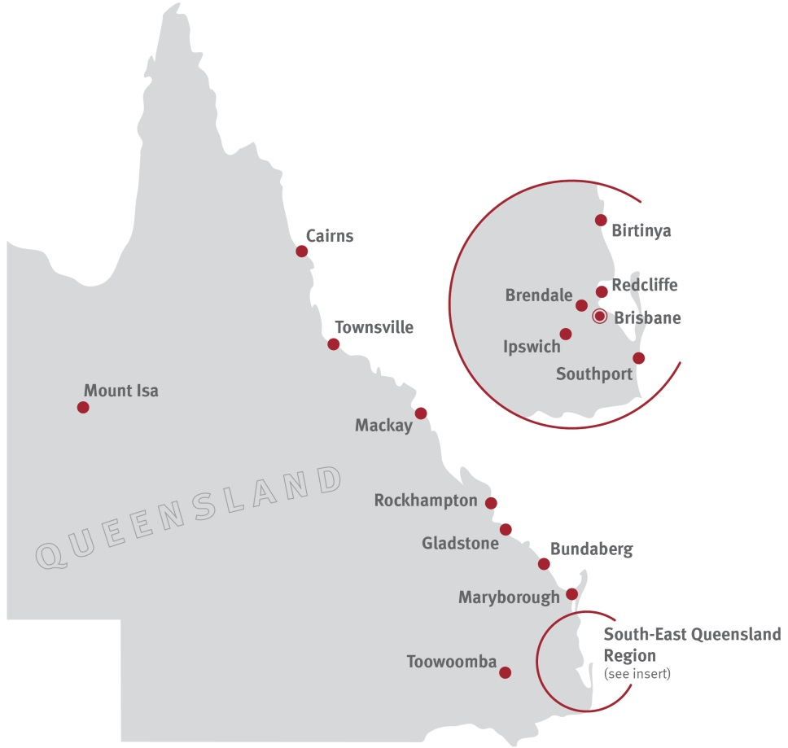
- Brendale
- Brisbane
- Birtinya
- Bundaberg
- Cairns
- Gladstone
- Ipswich
- Mackay
- Maryborough
- Mount Isa
- Redcliffe
- Rockhampton
- Southport
- Toowoomba
- Townsville
We also provide services outside of the above locations through the Queensland Government Agent Program and the local court networks. For further information on the location of our offices or outreach locations please refer to pages 50-52 of the report. Alternatively, you may also visit our website at www.pt.qld.gov.au.

Our vision
To be the independent trustee for Queenslanders providing security and peace of mind.

Our purpose
To lead the evolution and delivery of trustee, estate and administration services that make a positive difference in the lives of Queenslanders.
We provide professional and accessible:
Estate administration services
Financial management for those with impaired capacity for decision-making
Legal services
Trusts administration
Tax and investment services
Life-planning services including making Wills, EPAs and Advance Health Directives
Safe and secure storage of Wills and other life-planning documents
Real estate services
Philanthropy facilitation
We also:
- administer unclaimed moneys for the State of Queensland
- manage the estates of prisoners under Part 7 of the Public Trustee Act 1978
- carry out special functions of a public nature under Part 5 of the Public Trustee Act 1978
- promote and support community education on elder abuse.

Our legislation
The Public Trustee administers the Public Trustee Act 1978. We have a wide range of powers and functions, and operate under many other Acts including:
Acquisition of Land Act 1967
Adoption Act 2009
Agents Financial Administration Act 2014
Airports Assets (Restructuring and Disposal)
Act 2008
Associations Incorporation Act 1981
Body Corporate and Community Management
Act 1997
Building Units and Group Titles Act 1980
Charitable Funds Act 1958
Child Protection Act 1999
Child Protection (International Measures) Act 2003
Civil Partnerships Act 2011
Collections Act 1966
Corrective Services Act 2006
Criminal Proceeds Confiscation Act 2002
Debt Collectors (Field Agents and Collection Agents) Act 2014
Disposal of Uncollected Goods Act 1967
Drugs Misuse Act 1986
Financial Accountability Act 2009
Gaming Machine Act 1991
Guardianship and Administration Act 2000
Human Rights Act 2019
Industrial Relations Act 2016
Information Privacy Act 2009
Integrated Resort Development Act 1987
Land Act 1994
Land Sales Act 1984
Legal Profession Act 2007
Liquor Act 1992
Local Government Act 2009
Manufactured Homes (Residential Parks)
Act 2003
Mineral Resources Act 1989
Mixed Use Development Act 1993

Motor Dealers and Chattel Auctioneers Act 2014
National Injury Insurance Scheme (Queensland) Act 2016
Personal Injuries Proceedings Act 2002
Police Powers and Responsibilities Act 2000
Powers of Attorney Act 1998
Property Law Act 1974
Property Occupations Act 2014
Public Guardian Act 2014
Public Interest Disclosure Act 2010
Public Officers Superannuation Benefits Recovery Act 1988
Public Records Act 2002
Public Sector Ethics Act 1994
Public Service Act 2008
Residential Services (Accreditation) Act 2002
Residential Tenancies and Rooming Accommodation Act 2008
Retirement Villages Act 1999
Right to Information Act 2009
Sanctuary Cove Resort Act 1985
Second-hand Dealers and Pawnbrokers Act 2003
South Bank Corporation Act 1989
Storage Liens Act 1973
Succession Act 1981
Surrogacy Act 2010
Trust Accounts Act 1973
Trustee Companies Act 1968
Trusts Act 1973
Victims of Crime Assistance Act 2009
Workers’ Compensation and Rehabilitation
Act 2003
Work Health and Safety Act 2011
Youth Justice Act 1992

Official Solicitor
The Official Solicitor is the Public Trustee’s in-house legal advisor and is appointed pursuant to section 16 of the Public Trustee Act 1978.
The Official Solicitor provides advice and conducts litigation on behalf of the Public Trustee in many different roles. These services include:
- providing legal advice and conducting litigation in circumstances where the Public Trustee is appointed personal representative of deceased estates
- providing legal advice and conducting litigation when the Public Trustee is appointed administrator for an adult with impaired decision-making capacity
- conveyancing, leasing and other property related transactions on behalf of estates under administration and the Public Trustee as a corporation sole.
The Official Solicitor has identified a number of trends in the work undertaken on behalf of the Public Trustee, for example:
- The Public Trustee continues to be appointed administrator for an adult with impaired capacity in circumstances where that adult has been the subject of elder financial abuse. The Official Solicitor offers advice on the prospects of recovery of property or money misappropriated. These are often difficult cases where the adult for whom the Public Trustee is appointed administrator (as a result of the misappropriation) is of limited means to support litigation. In addition, it is often the case that the funds or property misappropriated have been dissipated by the person who has acted improperly.
- The Public Trustee continues to see an increase in the number of clients with complex financial affairs. For example, clients who have set up corporate structures for their Self-Managed Superannuation Fund, or to conduct a business.
- There continues to be a large number of referrals to the Official Solicitor in relation to family provision applications, often in circumstances where the Public Trustee has been appointed as financial administrator for an adult who is the child of a deceased person. There were 97 referrals to the Official Solicitor in the last year in relation to potential applications and 60 referrals to the Official Solicitor where the Public Trustee is administering the deceased estate. Importantly, of the 18 mediations that the Official Solicitor attended during the year involving a family provision application (whether representing the Applicant or the Respondent) 16 were resolved at mediation.
- Family provision applications are the most frequent kind of litigation the Official Solicitor is involved in for the Public Trustee. A family provision application is made to the Supreme Court or District Court by an eligible person seeking provision (or further provision) for their proper maintenance and support out of the estate of a deceased person. Part 4 of the Succession Act 1981 (“the Act”) deals with family provision applications. To be eligible the person must be a spouse, child or dependant of the deceased, as defined in the Act. The majority of these matters are resolved by negotiation and the court, exercising its discretion, making a final order. At times, the relevant parties might reach an agreement before any application is commenced in the court. There are timeframes which apply to bringing a family provision application. An estate is not able to be distributed until the relevant timeframe has passed or the matter has resolved.
- Where the Public Trustee is the administrator for an adult with a legal incapacity who has not been adequately provided for, the Public Trustee might bring the application against the estate as litigation guardian for the adult.
- Where the Public Trustee is administering a deceased estate, the Public Trustee as personal representative for the estate of the deceased would be the Respondent if someone commences a family provision application against the estate.
- The Official Solicitor acted for the Public Trustee in an unusual estate matter where a man had two identities. The man, going by a name with initials LW, died without having made a Will, it seemed. A death certificate had been issued for LW and the Public Trustee was granted an Order to Administer his estate on intestacy. As a result of the Public Trustee’s investigations, the Public Trustee then came to believe that LW was in fact the same person as a man whose name had the initials RAH, and who made a Will in 1971. The Public Trustee applied to the Supreme Court and sought orders:
- declaring that LW is one and the same as RAH
- correcting the Births, Deaths and Marriages Register to register RAH’s death
- revoking the Public Trustee’s Order to Administer on intestacy for LW and, subject to the formal requirements of the Probate Registrar, granting him an Order to Administer RAH’s estate according to his Will.
- Another kind of litigation in which the Official Solicitor acts for the Public Trustee relates to recovery of money or property for an adult with a legal incapacity who has had their funds or assets misappropriated. In one matter, the Public Trustee as administrator for the adult investigated, and took action on, the misappropriation by her former attorney son and daughter-in-law who had sold the adult’s property and used the sale proceeds to buy a property in the son’s own name. The Public Trustee lodged a caveat on the property (formal notice advising that the adult had an interest in the property) and commenced proceedings in the Supreme Court against the son and daughter-in-law. The court gave judgment and declared that the son held the property on constructive trust for the adult, his mother. The judge ordered that the adult be registered as the owner of the property and the son be removed as owner.

Our 2018–19 achievements

Driving value for clients
- $37.1 million in Community Service Obligations delivered at no cost to Government including:
- $28.1 million in fees rebated for clients with limited assets
- 28,426 Wills made at no cost to Queenslanders
- public education in areas such as Wills and EPAs with an emphasis on life-planning assistance
- funding for a range of community services through the Office of the Public Guardian and the Civil Law Legal Aid Scheme administered by Legal Aid Queensland
- financial management for 9151 adults with impaired decision-making capacity
- managing the estates of 548 prisoners
- acting as financial attorney for 258 clients
- managing 4467 trusts
- making 3684 EPAs
- accepting 2135 new deceased estates for administration and further reducing our average time to administer
- continuing to enhance frontline service delivery through:
- introducing our Client Service Charter and Standards, demonstrating our commitment to partnership, respect, ownership, understanding and delivery
- undertaking research on the client experience though client focus groups
- establishing a specialist Centre of Excellence for complex estate administration matters
- expanding and promoting our real estate model to enhance the overall client experience for deceased estates and financial management administration services including the sales of 267 properties valued at approximately $110 million.

Sustainable reinvestment to support business objectives
- investing in capital upgrades for regional offices in recognition of our commitment to regional service delivery
- investing in digital capability, to increase access to, reliability and scalability of Public Trustee services. Key initiatives have included:
- new contact centre capabilities
- fee estimator tools for services
- paperless communication options
- improved insight through analytics and primary customer research
- improved data centre and network services.

Strengthening confidence and value in our services
- strengthening relationships with a wide variety of stakeholders including other agencies and community groups, including:
- hosting our annual Queensland Wills Week to promote the importance of every Queenslander over the age of 18 having an up to date Will
- collaborating with the Department of Communities, Disability Services and Seniors, the Office of the Public Guardian and members of the community to promote and participate in elder abuse awareness activities
- strengthening our partnership arrangements across the private and public sector, with the aim of enhancing accessible and effective regional service delivery for all Queenslanders
- continuing to support philanthropic endeavours through the financial management of charitable and philanthropic trusts
- introducing a range of professional uniform options for frontline staff.

Targeted and effective service delivery
- supporting Public Trustee clients who are eligible for the National Disability Insurance Scheme, and ensuring all eligible clients are registered for the Scheme
- continuing to undertake client surveys to measure service effectiveness and client satisfaction for administration of deceased estates, financial management, trusts administration, and Wills and EPA services (results are available on page 18)
- fostering expertise in service delivery through operating six Centres of Excellence which allow us to achieve economies of scale (Testamentary Trusts, Minors Trusts, Group Housing, Prisoners, Residential Care and Advanced Residential Care)
- focusing, through our Centres of Excellence, on improved communication, faster and more consistent responses to client enquiries, streamlined processes and identifying best practices.

Engaging and empowering our workforce
- Engaging and empowering our workforce through:
- a suite of training modules and resources which all employees must complete upon commencement with the Public Trustee, and refresh annually, including Challenging Behaviour Management, Code of Conduct, Emergency Awareness, Work Health and Safety, Cybersecurity awareness, Information Privacy, Right to Information, Fraud and Corruption Control and Recordkeeping and File Management
- specialist disabilities training for more than 70 staff who have completed the Virtual Dementia TourTM, an immersive training program which simulates the experiences of people living with dementia
- frontline service delivery training (Technical Training) commencing with foundational skills for entry level officers and progressing to complex critical thinking, judgement and problem solving skills relating to Deceased Estates, Financial Management and Trusts
- awareness sessions aimed at empowering frontline teams to resolve issues at the first point of contact
- developing and delivering, in partnership with the Australian Institute of Management, the Client Experience and Delivery Supervisor Workshops for employees which focus on self-awareness and management, the skills to supervise and lead small teams, as well as how their work impacts on organisational outcomes
- a Leadership and Management Development Program for employees, delivered by the Queensland University of Technology (QUT) and aimed at developing the capability and competency of middle managers
- Working for Queensland Survey Workshops on employee engagement and empowerment. The workshops were conducted across 28 business areas and included activities based on local Highlight Reports and the development of local action plans to progress improvement activities.

As part of our ongoing commitment to deliver services which are valued by the community, the Public Trustee introduced some initiatives in 2018–19 aimed at enhancing our customer-focussed culture, including:
- Through their Eyes is an internal staff awareness campaign designed to highlight the customer perspective, enhancing customer centricity and improving confidence and morale. Featuring video testimonials from clients, visual aids and key messaging, the purpose of the campaign activities is to bring our customer personas to life, advancing staff connectedness to the organisation’s purpose to make a positive difference in the lives of Queenslanders, by improving customer engagement.
- In order to augment clinical, technical and leadership training undertaken by frontline teams, more than 70 frontline Trust Officers, our Disability Support Officers, and many of the Executive Leadership Team have completed the immersive Virtual Dementia Tour™. The purpose of this evidence-based training, developed by a geriatric specialist, is to raise awareness of the challenges those with dementia face, building deeper understanding and empathy for our clients’ situations. The training enables staff to experience real life scenarios including physical and mental challenges, and enhances their ability to recognise the behavioural and psychological symptoms of dementia. This in turn better equips staff to improve communications, building meaningful and positive connections with our ageing clients living with dementia, in order to provide better person-centred service delivery.

- Building on our understanding of the customer journey and current feedback, the Public Trustee has enlisted a community of customers to engage in the process of re-designing processes as part of our business transformation. This approach aims to ensure that the Public Trustee’s service delivery is tailored to meet changing customer needs and may be evidenced via more choice for customers in how they interact with us (for example, self-service through our website) or identifying which elements of our service delivery are of the most important to them as individuals.

Our strategic direction
Our strategic direction is documented in our Strategic Plan, which can be accessed on our website. The Strategic Plan sets the parameters for our strategic direction to staff, clients and stakeholders. It also outlines how we will contribute to the achievement of the Queensland Government’s objectives for the community, our priorities and our strategies. It includes performance indicators determining how our objectives will be measured.

The year ahead
To support our strategies, our key priority for 2019–20 continues to be our business transformation initiative to deliver organisational capability, process and technology changes aligned with our strategic objectives and to support future business needs.
The business transformation will enable us to deliver the following strategic objectives:
 | Drive value for clients through tailored services to meet changing needs |  |  | Embrace business transformation to enhance capacity to provide service excellence |  |  | Deliver services that are valued by the community and the Government
Our business transformation program will drive a culture of continuous improvement and business service evolution to meet current and future client needs including making it easier, faster and more efficient for people to access our information and services. The program includes replacing the Public Trustee’s core client information systems, digitisation projects which will deliver organisation efficiencies and sustainable business practice improvement, and establishing platforms to deliver a truly omnichannel service (using a variety of platforms) to allow our customers to interact with us in the way they prefer.
The program’s business service design has established our future service delivery requirements resulting in a transformation roadmap, future service blueprints and several future technology viewpoints. The Program Board ensures good governance practices, including consistent assurance processes to support the successful delivery of Information and Communications Technology initiatives, in accordance with the Queensland Government Chief Information Office’s Program and Project Assurance Framework.
The program is expected to result in improved records management and systems integration, allowing standardisation and automation of processes and enhanced workflow capabilities, enabling a focus on client service. In addition, there will be an increase in the number of channels available for client engagement - facilitating opportunities for client self-service.
The combination of efficiency gains, improved analytics and opportunities for self-service will drive improved client and staff interactions, and is anticipated to significantly enhance our clients’ experience.
Additional key priorities for 2019–20 include:
  - delivering quality frontline services that respond to changing client and community needs including providing ongoing financial management for Queenslanders with impaired financial decision-making capacity
  - driving value for clients by focussing on reducing the average time taken to administer deceased estates
  - continuing to provide a range of Community Service Obligations
  - further implementing digital transformation to enhance core business platforms and build strong digital capabilities
  - developing a Strategic Asset Management Plan to drive further investment in regional office facility upgrades to better serve clients
  - reviewing the investment objectives of the Common Fund
  - reviewing our fees and charges
  - continuing to provide services to the philanthropic sector.
In 2019–20, we will respond to key factors impacting on the Public Trustee to ensure our business operations continue to be sustainable and responsive to client needs by:
- enhancing knowledge and capability to enable us to meet the needs of clients with more complex asset structures or who are entering residential aged care
- delivering training and support to ensure Trust Officers are equipped to respond to amendments to the Guardianship and Administration Act 2000, including supported decision-making
- considering the service delivery impact of the Human Rights Act 2019 and implementing the necessary changes required by the legislation
- committing resources to support clients who may have a claim under the National Redress Scheme
- achieving service delivery efficiencies to enable us to meet the increasing demand for services eligible for Community Service Obligation rebates.
We are committed to providing efficient, quality services to our clients. We continue to redevelop regional offices to improve frontline service delivery, efficiency and accessibility for all clients, and to maintain appropriate work health and safety standards for clients and staff.
During 2019–20 capital expenditure is estimated to be $22.1 million comprised of:
$14.0 M
Business transformation program
$3.6 M
Building improvements
$4.5 M
Plant and equipment

Our strategic challenges and opportunities
In developing our Strategic Plan, we considered the major challenges facing Queensland now and into the future, and how they will impact the Public Trustee. We have identified a number of key risks and opportunities in achieving our vision and purpose, as illustrated below.
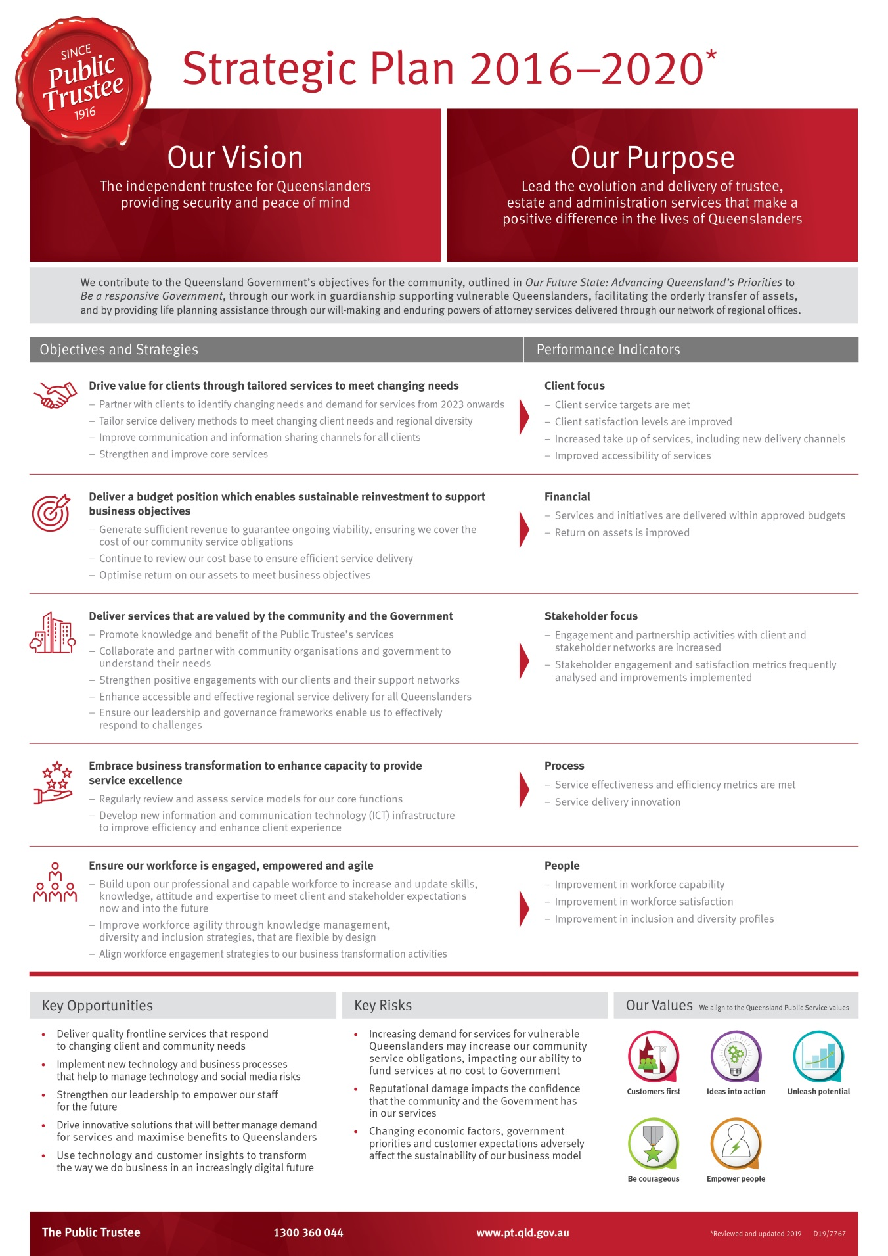

Non–financial performance
The Public Trustee contributes to the Queensland Government objective of being a responsive government through our work in guardianship supporting vulnerable Queenslanders, by facilitating the orderly transfer of assets, and by providing life-planning assistance through Wills and EPA services.

Queensland Government objectives for the community
The Public Trustee’s strategic objectives are aligned with the Queensland Government’s objectives for the community. In 2018–19, we invested significantly in being a responsive government by:
- partnering with a design research agency to undertake individual face-to-face customer interviews in Brisbane, Toowoomba and Cairns seeking our customers’ views on how we can improve our services and focus on the issues that will be most meaningful for them
- collaborating across business teams on a project to improve the value of the information we publish on our website about Wills, executor services and Enduring Power of Attorney documents. We started by testing the accessibility of our webpages and analysing digital insights and user needs. Through this process, we were able to identify gaps, which led to the development of new digital content. The information available is aligned to the Government’s Web Content Accessibility Guidelines to increase access for people with disabilities. It is also now aligned with common customer queries, and offers greater value to the community in general. This is a great example of our teams working together to make it easier for Queenslanders to access and use our services
- recruiting a Community Education Officer to enhance our relationships with our stakeholders and deliver a high quality program of education and information activities designed to improve the Queensland community’s access to our information, and its understanding of our products and services
- introducing an online survey tool for Wills customers, linked to Google reviews, to make it quicker and easier for customers to provide feedback on our will-making service
- listening to our customers’ requests for correspondence to be sent to them by email, and initiating work to develop a secure online portal
- increasing the searchability of real estate on our website, making it easier for Queenslanders to do business with us
- playing a strong role in preventing instances of elder abuse by contributing to the Queensland Government’s elder abuse awareness campaign which supports elder abuse prevention programs, and encouraging Queenslanders to plan for their later years and protect their interests by making an EPA.

Looking to the future, the Public Trustee will continue its focus on utilising advanced technology and digitisation of services to make it faster and more efficient for Queenslanders to access our information and services. In 2019–20, we will continue to demonstrate our commitment to Advancing Queensland’s Priorities and, particularly, the Queensland Government’s objective to be a responsive Government.

Community Service Obligations
A range of Community Service Obligations were provided in 2018–19 including:
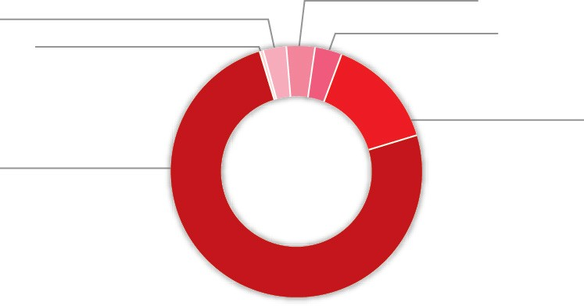
$1.2 M
Public community education and advice to the courts and tribunals in the areas in
which the Public Trustee has expertise
$1.2 M
A cash contribution to the Office of the Public Guardian
$1.3 M Other
$0.2 M
Civil Law Legal Aid - outlays written-off and administrative support
support
$28.1 M
Fees rebated for clients with limited assets
$5.0 M
Provision of a will-making service at no cost to Queenslanders

The total cost of Community Service Obligations delivered for the 2018–19 financial year was $37.1 million representing an increase of 4.2 per cent from the previous financial year (which was $35.6 million). An amount of $39.4 million is budgeted for 2019–20.
Category of Community Service Obligations | 2018–19  Actual | 2019–20  Budget
Fees rebated for clients with limited assets | $28,147,900 | $29,731,521
Fees rebated for principal residence and other | $783,355 | $775,970
Management of estates of prisoners | $564,719 | $681,188
Public community education and advice to the courts and tribunals in the areas in which the Public Trustee has expertise | $1,246,632 | $1,533,230
Providing a free will-making service to Queenslanders | $4,974,550 | $5,091,625
Cash contribution to the Office of the Public Guardian | $1,172,000 | $1,180,880
Civil Law Legal Aid - outlays written-off and administrative support | $233,706 | $381,291
Total | $37,122,862 | $39,375,705
Community Service Obligations are reported in our Financial Statements in two areas:
- deduction from fee revenue ($35.7 million 2018–19) where there is a rebate of fees or services provided at no charge
- expenditure ($1.4 million 2018–19) as grants and contributions towards other sector operations.
They are also reported in Budget Paper 2, Concessions Statement.

Summary of our performance
Client Experience and Delivery is the frontline interface with our clients and the community, providing:
- deceased estate administration - the Public Trustee administers deceased estates pursuant to Wills or on intestacy, delivering quality services to beneficiaries
- financial management - the Public Trustee acts as administrator for financial matters for clients with impaired capacity for decision-making pursuant to the Guardianship and Administration Act 2000 or as a financial attorney pursuant to the Powers of Attorney Act 1998
- a will-making service - the Public Trustee prepares Wills free of charge for all Queenslanders.
We measure our performance across the Client Experience and Delivery service area using three effectiveness measures and one efficiency measure.
The table below summarises our performance (quantifiable measures and qualitative achievements) against performance indicators in the Public Trustee’s Service Delivery Statement 2018–19 and those in our Strategic Plan 2016–2020. Our objective is to deliver a full range of professional, accessible and reliable personal trustee, financial and related services that meet client needs.
Client Experience and Delivery | 2018-19  Target/Est | 2018-19  Actual | 2019-20  Target/Est
Service standards  Effectiveness measures  Overall client satisfaction with the deceased estate administration service as measured by client satisfaction index1 | New measure | New measure | 70%
Overall client satisfaction with the financial management service as measured by client satisfaction index1 | New measure | New measure | 70%
Overall client satisfaction with Will preparation services2 | 90% | 93% | 90%
Efficiency measure  Cost per Will3 | $180 | $180 | $175
Notes:
- The satisfaction index is calculated by an independent market research provider on an annual basis. The index is calculated by summing 50% of the overall satisfaction score and 50% of a score derived from service and process factors, which have been weighted according to importance and combined to provide a single score.
- All clients preparing a Will with the Public Trustee receive a Wills Questionnaire. The Wills Questionnaire contains eight questions relating to the quality and delivery of the will-making service provided. The overall satisfaction level is calculated as a percentage of positive responses to total number of responses received.
- This service standard is calculated using the total cost of making free Wills divided by the number of Wills drafted and completed in the financial year. The total cost is comprised of direct and indirect costs specifically attributable to the will-making service including employee expenses, supplies and services, and apportioned overheads. The 2019-20 Target/Estimate has been adjusted due to continued refinement of the Public Trustee's cost allocation model.
Since 2013, the Public Trustee has conducted a client satisfaction survey specifically with beneficiaries of deceased estates at completion of administration, and with clients (and their carers) for whom the Public Trustee acts as a financial manager. In 2018–19, we extended the survey to include trust administration clients. The overall objective of the research is to gain understanding and insights into client experiences and the administration process.
The results of this research are highly valued and are used to develop and implement a range of operational improvements including communication and supervision strategies, and enhanced financial management, deceased estate and trust administration processes. The main aim of these changes is to improve the client experience and our service delivery.
Looking to the future, we will use the insights and information obtained through this research when embracing business transformation to enhance capacity to provide service excellence.

Philanthropy
The Public Trustee is trustee for the following leading philanthropic charitable trusts in Queensland.
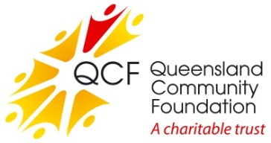
Queensland Community Foundation
The Queensland Community Foundation (QCF) was established in 1997 to provide a permanent source of philanthropic funding for charitable organisations to enable them to respond to the needs of the Queensland community.
The QCF continued to grow in 2018–19 and now has net assets of $94.7 million under management. During the year, QCF paid distributions to a broad range of charities close to $2.9 million.
For further information, visit www.qcf.org.au.
QCF Sub Fund: Gulf Area Community Social Development
Established under the umbrella of the QCF in 2000, this sub fund has net assets close to $6.7 million.
The sub fund supports the Gulf Area Community by providing grants to projects and initiatives that encourage cultural, educational, health and social development.
Queensland Aboriginal and Torres Strait Islander Foundation
The Queensland Aboriginal and Torres Strait Islander Foundation was established in 2008 and provides a secure, independent and perpetual funding source to advance the education of Aboriginal and Torres Strait Islander children and young people in Queensland through provision and promotion of scholarships.
The trust has net assets of $42.9 million.
Senior education scholarships of more than $2.6 million for young Queensland Aboriginal and Torres Strait Islander students were approved in 2018–19. In total, 10,184 students have been approved for scholarships since the foundation was established in 2008.
For further information, visit www.qatsif.org.au.

Lady Bowen Trust
Established in 2006, the Lady Bowen Trust aims to re-engage people experiencing chronic homelessness so they achieve genuine, positive and lasting outcomes. The trust supports Mission Australia which maintains Roma House, a facility to enhance clients’ life skills, confidence and resilience while assisting them to find secure accommodation.
The trust has net assets of $5.3 million with distributions paid totalling $90,000 in 2018–19.
For further information, visit www.ladybowentrust.org.au.
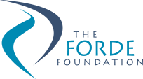
The Forde Foundation
The Forde Foundation was established in August 2000 in response to the findings of the Commission of Inquiry into Abuse of Children in Queensland Institutions, better known as the Forde Inquiry. The foundation is designed to support former residents of Queensland institutions. Financial support is provided to individuals for specific purposes such as dental care, education, training and personal development opportunities.
The foundation has net assets of approximately $4.1 million with distributions paid totalling $147,000 in 2018–19.
For further information, visit www.fordefoundation.org.au.
Gladstone Foundation
Established in early 2011, the Gladstone Foundation allows for industry funds to be channelled into this perpetual trust to provide social infrastructure and service needs in the Gladstone Region.
Specific purposes of the trust are relieving poverty, assisting the aged, relieving sickness or distress, advancing religion and education, providing child care services on a non-profit basis and other purposes which benefit the Gladstone Region.
Initial capital received by the trust was $13.5 million. The foundation has net assets close to $6.7 million as at 30 June 2019, with distributions paid totalling $0.86 million in 2018–19.
For further information visit www.gladstonefoundation.org.au.

Financial performance
The Public Trustee’s Financial Statements are included from page 56.
The Public Trustee recorded an operating loss of $0.8 million against a budgeted loss of $3.6 million. The financial performance benefited from higher than anticipated fee revenue, savings in employee expenses, lower computer expenses and an underspend relating to the business transformation program of works. There were partially offset by higher agency staff costs included in supplies and services.
A summary of our revenue and expenditure over the last seven financial years is as follows:
Revenue and Expenses
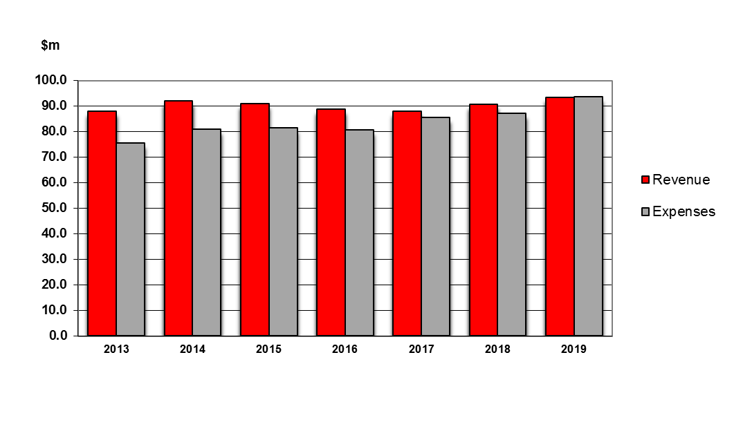
Our revenue sources in the last two financial years comprise the following:

Revenue sources | 2017–18 | 2018–19
Fees and Charges | 65% | 66%
Interest Revenue | 31% | 30%
Other Revenue | 4% | 4%
Total Revenue | 100% | 100%
Gross revenue from fees increased by 4.9 per cent from the previous year. The majority of Community Service Obligations are deducted from gross fees to arrive at net fees reported in the financial statements, with the remaining amount recorded in contributions expense. This year, we provided a total of $37.1 million in Community Service Obligations at no cost to the Queensland Government, which was a 4.2 per cent increase from the previous year. The main driver of the increase was a 5.4 per cent increase in fees rebated for clients with limited assets. As the Public Trustee is self-funded, these obligations were met from our own sourced revenue. Interest revenue was lower than the previous year due to a lower interest rate environment.
Our expenditure in the last two financial years comprises the following:
Expenditure | 2017–18 | 2018–19
Employee Expenses | 60% | 59%
Supplies and Services | 20% | 22%
Interest Expense | 13% | 13%
Depreciation and Amortisation | 3% | 3%
Contributions | 2% | 1%
Other Expenses | 2% | 2%
Total Expenditure | 100% | 100%
Total expenses increased 8.4 per cent from the previous year. Employee expenses increased as a result of a higher number of full-time equivalent staff coupled with a 2.5 per cent increase in staff salaries in the 2018–19 financial year. Non-employee expenses increased by 10.2 per cent due to higher supplies and services in comparison to the previous year. The increase in supplies and services expenditure is predominantly due to higher agency costs and consultancy fees.

Other Comprehensive Income
The Public Trustee holds interests in financial assets and various land and buildings located throughout the state from which our offices operate. These assets are recorded at fair value and are revalued periodically in accordance with Australian Accounting Standards. The gains and losses that result from these revaluations are recorded as other comprehensive income in the statement of comprehensive income.
All land and buildings were revalued during the 2018–19 financial year by independent valuers. Land and building values have increased by $12.5 million, with a corresponding increase in the asset revaluation surplus.
The market value of the Public Trustee’s financial assets recorded unrealised gains of $10.7 million due to an improved market value of the existing bond portfolio as interest rates decline. These factors resulted in a total other comprehensive increase of $23.2 million for 2018–19 which, combined with the operating loss, resulted in total comprehensive income of $22.4 million for 2018–19.

Statement of Financial Position

Total Assets
Total assets include cash, financial instruments (mainly short to medium term investments) and property, plant and equipment.
As at 30 June 2019, the Public Trustee held $982.4 million in assets, an increase of $27.1 million from 30 June 2018, mainly due to a larger investment portfolio compared to the prior year and an increase in the value of property, plant and equipment following the revaluation of land and buildings during the year.

Total Liabilities
The Public Trustee’s liabilities include amounts held for clients, amounts owing to staff for leave entitlements and amounts owed to suppliers. Total liabilities were $757.8 million as at 30 June 2019, an increase of $4.7 million from the previous year. The increase in liabilities is primarily due to an increase in amounts held on behalf of clients.

Statement of Changes in Common Fund Reserves
Total Common Fund reserves were $224.6 million as at 30 June 2019, increasing from $202.2 million in the prior year. Common Fund reserves include operating surpluses and asset revaluation surpluses achieved during the previous financial years.
A summary of our assets and liabilities over the last seven financial years is as follows:
Assets and Liabilities

Prospective Outlook
A budgetary deficit is forecast for the 2019–20 financial year due to the funding of the business transformation project. A balanced budget position is forecast (excluding the business transformation project).

Chief Finance Officer Statement
Our Chief Finance Officer (CFO) has fulfilled the responsibility as required by the Financial Administration Act 2009. The CFO has provided the Acting Public Trustee of Queensland with a statement about financial controls, in accordance with section 57 of the Financial and Performance Management Standard 2009. This statement was noted by the Audit and Risk Management Committee.

Public Trustee of Queensland Investment Fund – Growth Trust
The Public Trustee of Queensland Growth Trust (Growth Trust) was established to provide our clients with the opportunity to have their funds managed by the Public Trustee with the expert assistance of a professional investment manager.
The Public Trustee is the manager and trustee of the Growth Trust and is responsible for determining the investment objectives and strategy, arranging for the proper investment of all monies and ensuring the appointed investment manager achieves acceptable rates of return. The Public Trustee has appointed QIC Limited ACN 130 539 123 (QIC) as the investment manager of the Growth Trust.
The investment aim and objective of the Growth Trust is to provide a fully diversified investment strategy for those seeking long-term income and capital growth. The investment objective of the Growth Trust is to generate average returns (net of fees and costs) of CPI + 2.4% p.a. over rolling five year periods.
The Growth Trust currently gains exposure to various assets classes and investment sectors by investing in the QIC Growth Fund, while liquidity for the Growth Trust is managed by an investment of approximately one per cent in the QIC Cash Enhanced Fund or holding funds in cash at bank.
The asset allocation strategy of the Growth Trust is managed within the QIC Growth Fund, a diversified portfolio of assets including Australian and international shares, fixed interest, property, infrastructure, private equity, alternative assets and cash.
The investment objective of the Growth Trust and performance for the five year period ending 30 June 2019 is as follows:
Fund | CPI Objective  (after fees) | Objective  Target Return (%) | Annualised  Return (%)
Growth Trust | CPI + 2.4% over rolling 5 years | 3.72% | 5.87%
Further information on the Growth Trust is available in its Product Information Statement and additional information is available on our website at http://www.pt.qld.gov.au/about/publications/investments/.

Management and structure

Executive leadership
Experience and performance
The Executive Leadership Team provides the necessary guidance for the Public Trustee to achieve its strategic direction and goals, led by The Public Trustee of Queensland and drawing on the expertise of others when required.
Peter Carne
The Public Trustee of Queensland
Peter Carne brings over 30 years legal expertise to his statutory appointment as The Public Trustee of Queensland, a role he held from 2009 to 2014 and holds currently after being re-appointed in 2016. In addition to managing his own legal practice, Peter has held a number of public roles including CEO of the Queensland Law Society, Commissioner of the Queensland Legal Aid Commission and Director of the College of Law (Queensland). He has also held a number of honorary positions including President of the Queensland Law Society, Chair of the Queensland Law Society Specialist Accreditation Board and Director of the Queensland Law Foundation.
In 2003, Peter was awarded the Centenary Medal for his contribution to the legal profession. He has a Bachelor of Arts and a Bachelor of Laws from the University of Queensland and is a Fellow of the Australian Institute of Company Directors. In 2017, he was presented with life membership of the Queensland Law Society.
From 1999 until 2007 he was a board member of Tarong Energy Corporation and was a board member of Australia Post from 2009 to 2015, chairing the Audit and Risk Committee.
Peter graduated with an Executive Graduate Certificate in Business (Leadership through Coaching and Mentoring) with the QUT Business School in 2017.
Samay Zhouand*
Acting Public Trustee of Queensland and CEO
Samay Zhouand has more than 17 years’ experience in legal, accountability, governance and risk management advice and decision-making across government. Samay started his career as a lawyer with the former Department of Employment, Training and Industrial Relations. In his substantive role, Samay is the Chief Inspector of Queensland Corrective Services where he leads the objective and evidence informed scrutiny of the correctional system in Queensland.
Samay has a background in accountability, which is grounded in good administrative decision-making practices, integrity, objectivity and risk management. He has led multiple key functions ranging from legal services, information rights and ethical standards to internal audit and inspectorate functions, as well as acting in other key senior executive roles.
Samay has introduced key innovative governance, performance management, and operational effectiveness initiatives that advanced administrative outcomes. These include the establishment of an independent Probation and Parole inspection framework and key research insights and projects such as resilience programs, behavioural economics experiments and Australia’s first full MQPL+ Survey (measuring the quality of prison life) in collaboration with Cambridge University.
A barrister, Samay holds a Bachelor of Laws with Honours and a Bachelor of Arts, as well as qualifications in business and government.
Samay is committed to ensuring that the Public Trustee continues to provide a trusted, sustainable and client focused service for Queenslanders.
*Samay Zhouand commenced as Acting Public Trustee of Queensland and CEO on 13 June 2019.
Mark Crofton*
Deputy Public Trustee and Official Solicitor
Mark Crofton is the Deputy Public Trustee and Official Solicitor. In the latter role Mark heads the Office of the Official Solicitor, providing in-house legal advice to The Public Trustee of Queensland in many and varied capacities.
Mark has a Bachelor of Arts and a Bachelor of Laws (Hons) from the University of Queensland and a Masters of Laws from QUT. He was a 2011 Churchill Fellow. Mark has extensive experience practising law in both the private and public sectors and has spent a large part of his career undertaking legal work in relation to succession, trusts and clients with a disability.
*Mark Crofton left the Public Trustee on 19 July 2019 after taking a period of leave. Kathryn Williams was acting in the role of Official Solicitor at 30 June 2019.
Kathryn Williams
Acting Official Solicitor
Kathryn Williams has a Bachelor of Laws (Hons) from QUT, was admitted as a Solicitor of the Supreme Court of Queensland in 1987 and has a current Practising Certificate from the Queensland Law Society.
Commencing her career in the private sector, Kathryn then joined the Office of the Official Solicitor in 1991. Appointed as the Deputy Official Solicitor in 2012, Kathryn has previously acted as the Official Solicitor for two years (2014–2016). She has successfully completed the Practice Management Course through the Queensland Law Society.
Kathryn has extensive experience acting for the Public Trustee in both representative and corporate matters.
Amanda MacDougall
Executive Director, Client Experience and Delivery
Amanda MacDougall commenced with the Public Trustee in May 2017 as Executive Director, Client Experience and Delivery. In this role, Amanda is responsible for the customer experience across all product and service lines including regional service delivery, channel strategy and business growth via new business and product development. Her career spans 20 years, 15 of which have been in senior management roles leading large multi-disciplinary teams including operations, customer service, customer loyalty programs, sales, marketing, business development and general management across a diverse range of industries such as mining, banking, public sector and, most recently, financial services.
Amanda is committed to delivering robust commercial outcomes through an unrelenting focus on the customer, galvanising teams to execute the Strategic Plan. Her key focus is to lead the strategic change program to invigorate the customer experience across all product and service lines for the Public Trustee. Amanda has completed various business studies and is a graduate member of the Australian Institute of Company Directors.
Justine Callaghan
Executive Director, Investment and Finance Services and CFO
Justine Callaghan acted as the Executive Director, Investment and Finance Services and CFO from June 2017, and was appointed permanently to the role in February 2018. Justine is responsible for the financial management and investment frameworks of the Public Trustee. Her former role within the Public Trustee was the Director Finance from October 2015. Justine has extensive experience in senior finance leadership roles predominantly in the mining industry, in particular with Glencore (formally Xstrata and Mount Isa Mines Limited).
Justine has a Bachelor of Commerce (majoring in Accounting) from the University of Southern Queensland and is a Certified Practising Accountant and a Certified Management Accountant. Justine is a graduate member of the Australian Institute of Company Directors.
David Cook
Executive Director, Digital and Technology
David Cook commenced as the Executive Director, Digital and Technology in April 2017 and is accountable for Digital Business and Technology Strategy, Enterprise Change, Information Systems and Records Management for the Public Trustee. His career has included roles leading operations, strategy, customer service, account management, security/business resilience, continuous improvement, consultancy, merger and acquisition and commercial management across defence, retail, high technology, resources and financial services. David’s focus is on establishing the Public Trustee’s digital customer service channels, in addition to being the senior responsible officer leading its digital transformation program.
David has a Bachelor of Business (Dist), an MBA (Dist) and has undertaken training in Experience and Digital Design, Behavioural Finance, Negotiation, Project Management, Prosci Change Management, Six Sigma, Lean, Risk Management, Security and Technology Governance. David is a graduate member of the Australian Institute of Company Directors and is an experienced not-for-profit Director and Chair.
Erica Gallagher
Senior Director, Human Resource Services
Erica Gallagher commenced in January 2016 as the Director Human Resources. Erica’s role was later changed to Senior Director, Human Resources and MarComms when the executive management structure was reviewed in 2016. Erica’s career spans over 30 years, 15 of which have been in senior leadership roles. Erica has worked in government and the not-for-profit disability sector in Western Australia. Erica is committed to contemporary human resource practice and the enhancement of the human resource profession by focusing on employee engagement, organisational culture, diversity of perspective, capability enhancement, performance development and managing the complexity of the workforce in a global environment of digitalisation and intergenerational challenges.
Erica was the Australian Human Resources Institute (AHRI) Western Australia State President and was a Councillor on the AHRI Queensland Council.
Josephine Giles
Senior Director, Governance and Risk
Josephine commenced as Senior Director, Governance and Risk in May 2017. In this position, Josephine is responsible for leading all governance and related functions for the Public Trustee, including government relations, statutory reporting, risk management, complaints management, fraud and corruption control, business continuity planning, information privacy, Right to Information and administrative access and release. Josephine has extensive experience across Queensland Government agencies including Queensland Health, Queensland Treasury and the Department of the Premier and Cabinet.
Josephine has a Bachelor of Commerce (majoring in Accounting and Finance) and a Graduate Certificate in Policy Analysis from Griffith University. She is a graduate member of the Australian Institute of Company Directors.
Elissa Pearse*
Senior Director, Office of the CEO
Elissa works closely with The Public Trustee of Queensland and the Executive Leadership Team on strategy and business planning, and provides secretariat support to the Audit and Risk Management Committee.
Prior to joining the Public Trustee, Elissa worked in the financial services industry in the United Kingdom and Australia. Elissa has a Bachelor of Business (majoring in Banking and Finance) and a Bachelor of Laws (Hons) from QUT and a Graduate Diploma in Legal Practice from the College of Law, Sydney. She is undertaking an Executive MBA through the QUT Business School.
*Elissa Pearse performed the role of Senior Director, Office of the CEO until 7 September 2018, and is currently Acting Senior Director, Strategic Initiatives. Shelley Grace was acting in the role of Senior Director, Office of the CEO at 30 June 2019.
Shelley Grace
Acting Senior Director, Office of the CEO
Shelley commenced as the acting Senior Director, Office of the CEO following a period of service as the Business Planning and Reporting Manager within the Finance Program. Shelley works closely with the Public Trustee of Queensland and the Executive Leadership Team on strategy and business planning, and also provides secretariat support to the Audit and Risk Management Committee.
Shelley has a Bachelor of Business (majoring in Professional Accounting) from QUT and is a Chartered Accountant.

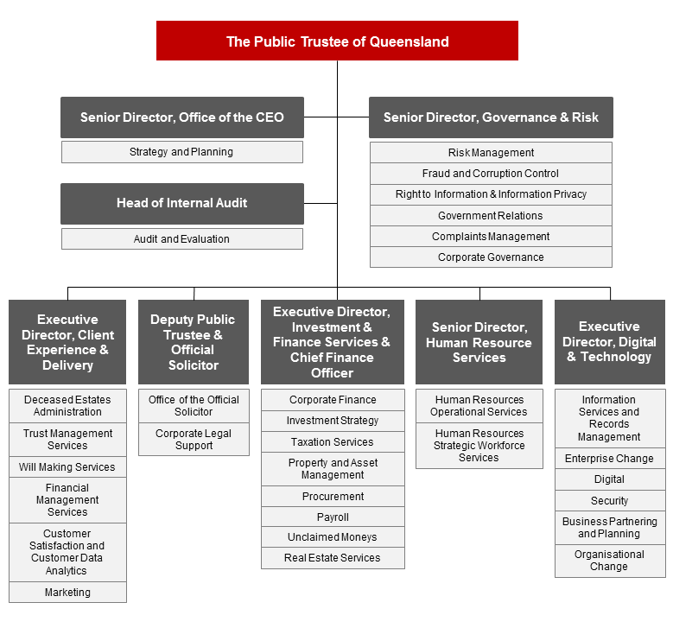

Senior internal management committees
The Public Trustee has established a range of internal committees to support all areas of operation. The committees have varying roles and functions and are established for specific purposes either because of a legislative imperative or in response to the needs of the organisation.
Our leaders’ membership across these governance committees demonstrates our commitment to delivering services for Queenslanders in a transparent and accountable way. Our committees are integral components of the Public Trustee’s governance arrangements that also include performance reporting and internal and external conformance, to ensure we apply and adhere to better practice and standards in all areas of our operations.

Executive Leadership Team
The ELT is the senior leadership team for the Public Trustee. The purpose of the ELT is to:
- support The Public Trustee of Queensland in meeting the responsibilities outlined in the Public Trustee Act 1978 and other relevant legislation
- provide leadership, direction and guidance to ensure that the Public Trustee provides quality trustee, estate and financial administration services to the people and Government of Queensland.
The ELT undertakes the following functions:
- determining the Public Trustee’s vision, purpose, and strategic objectives
- developing and monitoring implementation of strategic initiatives
- making recommendations to the Public Trustee in relation to strategic planning, policy setting, budget and resource allocation
- identifying strategies and building organisational capability to the future sustainability of the Public Trustee
- promoting a risk management culture and committing to organisational risk management principles including assessing the material business and strategic risks facing the organisation
- ensuring the:
- efficient, effective and equitable use of current and future Information and Communication Technology resources
- contribution of Information and Communications Technology resources towards business direction at an agency, cross-agency, government and cross-jurisdictional level.
Membership of the ELT is determined by The Public Trustee of Queensland. The members as at 30 June 2019 were:
- The Public Trustee of Queensland (Chair)  - Deputy Public Trustee and Official Solicitor  - Executive Director, Client Experience  and Delivery  - Executive Director, Investment and Finance Services and CFO | - Executive Director, Digital and Technology  - Senior Director, Human Resource Services  - Senior Director, Office of the CEO  - Senior Director, Governance and Risk.
The ELT met 27 times during 2018–19.

Organisational Performance Group
The role of the Organisational Performance Group is to provide a forum to share information across the Public Trustee through:
- overseeing the implementation of the Public Trustee’s operational and specific purpose plans developed to support the Strategic Plan
- monitoring ongoing organisational performance.
The core functions of the Organisational Performance Group are to:
- monitor and review organisational performance against delivery of existing priorities, operational and specific purpose plans
- monitor organisational performance against key metrics
- ensure appropriate action is being taken where necessary to address any performance issues
- share information in relation to future developments that may impact strategic direction including policy changes, technological developments, research activities and legislative and regulatory requirements.
Membership of the Organisational Performance Group is determined by The Public Trustee of Queensland. The members as at 30 June 2019 were:
- The Public Trustee of Queensland (Chair)  - Deputy Public Trustee and Official Solicitor  - Executive Director, Client Experience  and Delivery  - Executive Director, Investment and Finance Services and CFO  - Executive Director, Digital and Technology  - Senior Director, Human Resource Services  - Senior Director, Office of the CEO  - Senior Director, Governance and Risk  - Director, Finance | - Director, Investment and Taxation Services  - Director, Property  - Director, Estates and Trusts  - Director, Disability Services  - Director, Regional Services  - Director, Client Experience  - Deputy Official Solicitor  - Director, Legal Services  - Chief Information Officer  - Director, Digital  - Manager, Marketing and Communication  - Head of Internal Audit.
OPG met 10 times during 2018–19.

Workplace Health and Safety Committee
The Public Trustee has a Workplace Health and Safety (WH&S) Committee to ensure compliance with the Work Health and Safety Act 2011.
Members of the committee are:
- Senior Director, Human Resource Services (Chair)  - Manager, Human Resource Operational Services  - Senior Coordinator, WH&S and Injury Management  - Coordinator, WH&S and Injury Management | - Property Manager  - Health and Safety Representatives from each regional location and one from each floor in the Brisbane office  - Regional Managers (where the regional office has not nominated a Health and Safety Representative).
The committee met three times during 2018–19.

Agency Consultative Committee
The key objective of the Agency Consultative Committee is to provide a mechanism for management and Union delegates to identify, raise and discuss current or emerging issues such as workload management, organisational change, training and development and other related matters.
The committee’s core membership includes:
- a Union Organiser  - three Union Delegates  - Senior Director, Human Resource Services (Chair)  - Executive Director, Client Experience  and Delivery | - Executive Director, Investment and Finance Services and CFO  - Manager Human Resource Operational Services / Principal Industrial Relations Officer  - Executive Officer (minute taker).
The committee met four times during 2018–19.

Strategic Asset Management Committee
The objectives of the Strategic Asset Management Committee are to:
- coordinate the development, review and update of the Public Trustee’s Strategic Asset Management Plan and monitor progress of key initiatives
- act as the Program Board for organisational projects, including reviewing and endorsing project mandates, briefs and business cases for recommendation to the ELT, including funding and prioritisation.
Members of the committee are:
- Executive Director, Investment and Finance Services and CFO (Chair)  - Director, Investment and Taxation Services  - Director, Regional Services  - Director, Estates and Trusts  - Director, Client Experience | - Director, Disability Services  - Director, Property  - Director, Finance  - Chief Information Officer  - Deputy Official Solicitor.

Standing invitees are:
- The Public Trustee of Queensland  - Deputy Public Trustee and Official Solicitor  - Executive Director, Client Experience  and Delivery  - Executive Director, Digital and Technology | - Senior Director, Office of the CEO  - Senior Director, Governance and Risk  - Senior Director, Human Resource Services  - Manager, Enterprise Change Office.
Observers and other participants include Project Senior Responsible Officers and Project Managers, as required.
The committee met seven times during 2018–19.

Boards and committees with external membership

Public Trust Office Investment Board
The Public Trust Office Investment Board (the Board) is established under section 21(1) of the Public Trustee Act 1978. The functions of the Board are to control and manage the investments of the Common Fund, and to provide advice to the Public Trustee on the investment management of the Public Trustee of Queensland Growth Trust.
Significant achievements of the Board in 2018–19 were:
- reviewed the credit policy, taking into consideration the risk appetite of the organisation and the counterparty risks that prevail in the global financial environment
- reviewed the operating limits for interest rate and credit risks
- approved and monitored the investment strategy of the Common Fund taking into consideration the continued historically low yield environment
- endorsed revised benchmarks for interest rates payable to clients
- endorsed the interest rates payable to clients.
The Public Trustee of Queensland Growth Trust is audited by the Auditor-General.

Remuneration
Position | Name |  | Meetings/  sessions attendance | Approved annual, sessional or daily fee | Approved  sub-committee fees if  applicable | Actual fees received (GST exclusive)
The Public Trustee of Queensland | Peter Carne |  | 3 | N/A | N/A | N/A
External Member | Henry Smerdon |  | 3 | Meeting fee -  4 hours or  less $400 | N/A | $1200
External Member | Sandra Birkensleigh |  | 3 | Meeting fee -  4 hours or  less $400 | N/A | $1200
Officer of the Department administered by the Treasurer | Geoffrey Waite |  | 3 | N/A | N/A | N/A
No. scheduled meetings |  | 3
Total out of pocket expenses |  | N/A
Under the Public Trustee Act 1978, the Public Trust Office Investment Board must consist of at least three members, one of whom shall be The Public Trustee of Queensland and one of whom shall be an officer of the Department administered by the Treasurer.
The Public Trust Office Investment Board has adopted the Code of Conduct for the Queensland Public Service.

Audit and Risk Management Committee
The Audit and Risk Management Committee is an independent advisory body established to assist The Public Trustee of Queensland in fulfilling the Accountable Officer’s responsibilities under the Financial Accountability Act 2009, Financial and Performance Management Standard 2009 and other relevant legislation.
The committee operates under terms of reference established in accordance with the Audit Committee Guidelines – Improving Accountability and Performance published by Queensland Treasury.
The committee assists with reviewing:
- financial statement preparation processes and oversight
- the risk management framework
- the fraud and corruption control framework
- internal audit plans for endorsement
- actions from internal and external audit reviews.
The Audit and Risk Management Committee met four times during 2018–19.

Voting members of the Audit and Risk Management Committee for 2018–19 were:

Name | Details
Sandra Birkensleigh | External Chair
Glenn Poole | External Member (until December 2018)
Felicity Cooper | External Member (from March 2019)
Janine Walker AM | External Member
Mark Crofton | Nominated representative of The Public Trustee of Queensland (until June 2019)
Kathryn Williams | Nominated representative of The Public Trustee of Queensland (from June 2019)
Standing invitees of the Audit and Risk Management Committee are:
- The Public Trustee of Queensland
- ELT members
- Queensland Audit Office
- Head of Internal Audit.
The recommendations made by the Queensland Audit Office during 2018–19 were considered by the committee and are being appropriately addressed by management.

Current member profiles
Sandra Birkensleigh, External Chair is an experienced non-executive director currently holding a number of Board positions, including with the National Disability Insurance Agency. She is a Council member of the University of the Sunshine Coast and Chair of their Audit and Risk Committee, and an independent member of the Audit Committee of the Reserve Bank of Australia. A qualified chartered accountant, she was formerly a partner of PricewaterhouseCoopers. Sandra has recently been appointed by the Institute of Internal Auditors-Australia as the Chair of its newly established Financial Services Committee.
Felicity Cooper, External Member has a strong financial, risk, technology and advisory background. A qualified Chartered Accountant, and currently Chief Internal Auditor at Brisbane City Council, Felicity is a member of the Australian Institute of Company Directors and Chartered Accountants Australia and New Zealand. Felicity has significant risk and governance experience involving complex regulators and has led multiple million-dollar digital transformation programs for Commonwealth, State and Local Governments across Australia.
Janine Walker AM, External Member is an experienced Chair and Board Director and an Adjunct Professor in the Griffith Business School. She is currently Chair of the Board and a member of the Finance Committee and the Audit and Risk Management Committee of the Metro South Hospital and Health Service, and the independent Chair of the Workplace Relations Committee of the Queensland Catholic Education Commission.
Mark Crofton, Deputy Public Trustee and Official Solicitor, Nominated Representative of The Public Trustee of Queensland (until June 2019) - refer to page 26.
Kathryn Williams, Acting Official Solicitor, Nominated Representative of The Public Trustee of Queensland (from June 2019) – refer to page 26.
Remuneration payments
Remuneration to external members during the 2018–19 financial year is detailed below.
Remunerated committee members | Amount (GST exclusive)
Sandra Birkensleigh | $18,700
Glenn Poole | $6250
Felicity Cooper | $6250
Janine Walker AM | $12,500
Total | $43,700
Voting members are required to comply with the Code of Conduct for the Queensland Public Service during their term.
Athena Program Board
The role of the Board is to set the direction of the Program, drive the Program forward to deliver outcomes, realise benefits, and oversee the overall progress of the Program.
Members of the Board are:
- Executive Director, Digital and Technology (Chair)  - Executive Director, Client Experience and Delivery  - Director, Client Experience  - Executive Director, Finance and Investments and CFO  - Deputy Official Solicitor  - Senior Director, Human Resource Services | - Chief Information Officer  - Director, Digital  - External Advisor  (Catherine De Ruyter De Wildt)  - Program Manager  - Executive Assistant, Digital and Technology (Secretariat)

Standing invitees are:
- A representative of the Governance and Risk Directorate
- A representative of Internal Audit
- A representative of the Enterprise Change Office
- All members of the ELT.
In 2019, the Program Board appointed an External Advisor to provide expert knowledge and advice on issues relevant to the program. The External Advisor is not remunerated.
The Board met 10 times during 2018–19.

External member profile
Catherine de Ruyter de Wildt, External Member has extensive experience in management consulting, business and Information Technology strategy, business development, client engagement and stakeholder management. With qualifications in business and management, Catherine’s focus is on digital strategy development and digital transformation management. Her expertise also encompasses Information Technology and fraud risk management, human centered design, and large and complex program management.

Public Sector Ethics
Our employees are bound by the Code of Conduct for the Queensland Public Service. The Public Trustee maintains high ethical standards that support and underpin our fiduciary responsibilities.
Our Strategic Plan has an emphasis on the delivery of quality frontline services by providing our clients with professional and effective services in a responsive manner. To deliver quality frontline services, we must have competent employees who act in an ethical manner.
In delivering quality services, we continued to enhance our culture as an ethical workplace through a range of strategies which raised awareness of ethical standards and which supported ethical decision-making and behaviour. In 2018–19, those strategies included:
- educating employees about ethical standards required in the workplace through our orientation program and mandatory online compliance training including:
- Code of Conduct
- fraud and corruption control
- information privacy
- right to information
- complaints management
- recordkeeping and file management
- cybersecurity awareness
- supporting line managers in inducting new staff by providing the following resources on
our intranet:
- induction guidelines
- induction planner
- new employee induction manual
- ensuring we have the relevant policies and procedures in place to support our compliance with the Public Service Act 2008 and the Public Sector Ethics Act 1994
- promoting to all employees the Public Service Commission Directive on declaring gifts and benefits received, given and declined
- updating our Fraud and Corruption Control policy, procedure and plan
- complying with the Public Interest Disclosure Act 2010 through having the required policy and procedures available on our website
- reviewing human resource policies and procedures to align with the Queensland Public Service values and Code of Conduct for the Queensland Public Service.

Public Sector Values
The Queensland Public Service values are the cornerstone of our workplace culture and are underpinned by the Public Sector Ethics Act 1994 and the Code of Conduct for the Queensland Public Service.
During 2018–19, we continued to embed and implement the values into our organisation as demonstrated below.
Customers first
- We continued to provide quality frontline services in estate administration, financial management, trusts management and the Will and EPA making service.
- We operated six Centres of Excellence for Testamentary Trusts, Minors Trusts, Group Housing, Prisoners, Residential Care and Advanced Residential Care to provide better services for these client groups.
- We provided ongoing sponsorship to the Department of Communities, Disability Services and Seniors’ elder abuse awareness campaign.
- We undertook annual client satisfaction surveys to measure how we are meeting our clients’ expectations.
- We continued to provide specialised technical training to Trust Officers at all levels in order to provide excellent service to clients and to minimise risk.
- We progressed the Through Their Eyes campaign, encouraging staff to consider a different perspective, become more familiar with our customer profiles, and gain a deeper understanding of their frustrations and pain points. By developing more insight, we can build on the development of greater empathy for our clients’ journeys when faced with uncertainties, grief and frustration.
- We developed Client Service Standards that clearly define our service expectations for client interactions that support strong customer relationships. The Standards are aligned to our Client Service Charter, and identify our commitment to our customers (Partnership, Respect, Ownership, Understanding and Delivery – PROUD).
Ideas into action
- We invested in the enhancement of technology and review of service delivery models and locations to better meet growing and changing demographic needs of Queenslanders.
- We upgraded facilities to better service our regional and remote clients.
- We delivered enhancements to frontline service delivery in response to client satisfaction survey outcomes.
- We delivered the Evolving Business Capability Conference 2018 to approximately 100 middle and senior managers from across the organisation. The Conference focused on their development in the areas of creative and innovative thinking and leadership capability.

Unleash potential
- We continued to provide professional and industry standard training to employees to equip our workforce with the right skills, knowledge and attitude to meet client and stakeholder expectations. This includes specialised, organisation specific, mandatory online compliance training and technical training for frontline service delivery employees and managers.
- We delivered the Corporate Orientation program every eight weeks to new employees.
- We developed and delivered, in partnership with the Australian Institute of Management, the Client Experience and Delivery Supervisor Workshops for employees at Administrative Officer Level 4 and 5 classifications. These Workshops were focused on self-awareness and management, the skills to supervise and lead small teams, as well as how their work impacts on organisational outcomes. Workshops will be continuing into 2019–20.
- We continued to provide assistance to individual employees to build their professional capabilities through the support and management of our Study and Research Assistance Scheme.
Be courageous
- We undertook primary, face to face research with our customers to explore how we could improve and redesign the future state of Public Trustee services and to understand how we can design services and products that other people would also want to use – including identifying successes and mistakes to ensure we focus on the right things from our customers’ perspectives.
- We continued to make considered decisions in the interests of our often vulnerable clients, within a contested interests environment where clients and other stakeholders hold diverse views.

Empower people
- We developed and implemented a range of initiatives as a result of the feedback received through the Working for Queensland Survey, including developing Workshop Action Plans for each region/business area.
- The Client Experience and Delivery Induction program provided new Trust Officers with basic foundational skills and knowledge within the first eight weeks of joining. The aim of the program is to provide employees with a consistent technical induction as they begin their career with the Public Trustee.
- The Public Trustee has implemented a Leadership and Management Development Program in partnership with QUT. This program has aimed to provide our middle management employees at the Administrative Officer Level 6/Professional Officer Level 4 to Administrative Officer Level 8/Professional Officer Level 6, an opportunity to develop strategic leadership skills and behaviours. Focus has been on developing their leadership and management understanding while applying their learning to real internal scenarios. The first cohort had 31 participants while the second cohort had 27. The third and final cohort of 25 graduated in August 2019.

Working for Queensland Survey 2018
In September 2018, a total of 512 employees participated in the Public Sector 2018 Working for Queensland Survey. This response rate of 81% was an increase from our 2017 response rate of 76%. Similarly to previous years, the questions related to employee engagement, job empowerment and organisational leadership.
Survey results were discussed with employees through face-to-face workshops which were held during February to April 2019. In total, 28 Working for Queensland workshops were delivered by the Human Resource Services team. The workshops provided an overview of workgroup results and an opportunity to develop local action plans.
A number of key themes were identified from the action plans, which are being collated to identify initiatives that may be beneficial to apply across the Public Trustee. Work will continue throughout the next year to implement the action plans.

Governance – risk management and accountability

Governance and Risk Directorate
The components of the Public Trustee’s governance framework establish the principles, relationships and processes that guide our work. We are committed to legislative compliance and ethical behaviour, and to meeting public expectations for probity, accountability and transparency.
The Governance and Risk Directorate is responsible for administering, supporting and guiding the Public Trustee’s governance processes.
Governance and Risk’s functions include:
- statutory reporting including annual reporting and preparing our Service Delivery Statement
- managing the risk management framework
- fraud and corruption control
- government relations
- complaints management
- right to information, information privacy, and administrative access and release
- developing, reviewing and implementing related policies and procedures.
Governance and Risk is responsible for effective implementation of and compliance with a number of legislative requirements for the Public Trustee, including the Right to Information Act 2009, Information Privacy Act 2009 and Public Interest Disclosure Act 2010.
Some of our performance highlights in 2018–19 are detailed on the next page.
- We engaged one-on-one and through team meetings, working groups, project boards and other forums to discuss, advise and collaborate on diverse governance issues in order to enhance governance capability across the Public Trustee.
- We shared information and learnings, and demonstrated our commitment to better practice, through participation in the whole-of-Government Strategic Management Network focussed on planning, performance reporting and related topics.
- We refined the information captured in the Complaints Management System to ensure it enables the Public Trustee to identify improvements that can be made to the organisation, its services and the way they are delivered. In 2018–19, there were 539 complaints recorded indicating a continued downwards trend from 654 complaints in 2016–17 and 610 in
2017–18.

- We worked closely with our colleagues in Client Experience and Delivery to develop the process, and subsequent training of staff, to record frontline complaints.

- We achieved positive findings in an Office of the Information Commissioner Audit of Awareness of Privacy Obligations. The Audit examined whether selected Queensland Government agencies appropriately educated and trained their employees about their obligations under the Information Privacy Act 2009. The Public Trustee was one of the organisations subject to the audit. Human Resource Services provided extensive assistance in gathering information relevant to the scope of the audit. The Public Trustee provided feedback on the positive findings and the Report was tabled in Parliament on
12 February 2019.

- We confirmed our commitment to improving access to information for the community and a better understanding of privacy rights and responsibilities, as part of a coordinated training and communications program throughout the year. For example, we raised awareness of:
  - the importance of valuing personal information during Privacy Awareness Week with activities, promotions and by engaging in team meetings across various program areas of the Public Trustee
  - every individual’s right to access government-held information, if it is in the public interest to do so, through activities celebrating Right to Information Day 2018 with a focus on ‘Trust and Transparency’.
Governance and Risk has identified a recent trend developing with requests for access to archival material of the Public Trustee. The Department of Aboriginal and Torres Strait Islander Partnerships (DATSIP) is reviewing deceased estates of Aboriginal people whose financial affairs were controlled under the Aboriginals Preservation and Protection Act 1939 where their estate was not distributed, but instead was transferred to the Aborigines Welfare Fund. This project is part of a Queensland Government commitment.
Established in 1943 for the general benefit of Aboriginal people under the provisions of the Aboriginals Preservation and Protection Act 1939, the Aborigines Welfare Fund comprised income from a range of sources including child endowment benefits paid for children in mission dormitories, unclaimed estates of deceased or missing Aboriginal people, compulsory deductions from Aboriginal people’s wages, and income earned from grazing and agricultural enterprises. The Queensland Government Response to the Stolen Wages Reparations Taskforce Report (Reconciling Past Injustice) identified that the Queensland Government would ensure that reassessment of the deceased estates and relevant distribution of funds would be progressed as a matter of priority.
Another active initiative is by the DATSIP Home Ownership Team, which is seeking information from the Public Trustee to assist in identifying beneficiaries to portions of estates in accordance with section 60 of the Aboriginal and Torres Strait Islander Communities (Justice, Land and other Matters) Act 1984 with regards to perpetual lease entitlement under the Aboriginal and Torres Strait Islanders (Land Holding) Act 1985.
Governance and Risk is managing an increasing number of requests from DATSIP for information from our records relating to the estates of individuals of Aboriginal background, to assist with their research. Some matters have required recalling the record from the Queensland State Archives and preparing detailed responses to DATSIP. The Public Trustee anticipates receiving more requests in the coming months as the project progresses.
The team has also managed a diverse range of privacy and information access matters during the 2018–19 year, including:
- undertaking a Privacy Impact Assessment for geographical mapping by the Queensland Government Statistician’s Office on behalf of the Public Trustee
- managing the release of documents to new administrators, executors or former clients, with over 20,000 documents released relating to 16 clients in 2018 – an example of the voluminous work that is often involved in responding to requests for information through administrative release processes

- assisting a local council with access to documents relating to the functions of the Office of Insolvency and historical ownership of a property transferred by ‘Transmission by Insolvency’ to the Public Curator of Queensland. The parcel of land concerned contains a prominent land feature in the local landscape that was named and gazetted by the Queensland Government. The current landowner applied for approval to operate a quarry from the land; the application was refused and is now subject to appeal. The documents were poorly preserved and extremely fragile, making inspection and research a painstaking and delicate task. After careful consideration, the Public Trustee’s Privacy Officer was able to assist the council by providing copies of certain documents relating to the land and the original landowner, after whom the prominent land feature was named. The council was very appreciative and it is hopeful this prominent land feature can be preserved.

Risk management
Risk management at the Public Trustee is governed by our Risk Management Framework, a core component of our overall corporate governance. Aligned to the AS/NZS ISO 31000:2009 Risk Management Standard and designed for our specific business and organisational environment, the framework encompasses policies, procedures, systems and strategies that effectively manage our risks through regular engagement and consultation.
In line with its purpose to support the CEO, the ELT is committed to promoting a risk management culture and to organisational risk management principles. Risks are identified and monitored on an ongoing basis to ensure they adequately reflect the current operating environment and are brought to the attention of ELT where required. Significant risks at organisation and program area levels are regularly reviewed and reported to the ELT and Audit and Risk Management Committee.
In 2018–19, Governance and Risk progressed a body of work aimed at increasing risk maturity and strengthening the Framework foundations including:
- developing a Risk Appetite Statement to establish baseline risk levels the Public Trustee is willing to accept in pursuing its strategic and operational objectives. This Statement enables a consistent approach across programs in understanding and managing risks in day-to-day operations, particularly in decision-making
- conducting risk workshops with management teams to identify and assess significant risks across the Public Trustee. Individual program registers, and the Material Business and Strategic Risk Register, are reviewed by risk owners as part of regular management meetings to enable informed decision-making
- continually enhancing the Risk Management Framework for consistency of risk assessment, monitoring and reporting in line with the ISO 31000:2018-2 Risk Management – Guidelines and other applicable standards
- improving risk metrics defining the consequence and likelihood levels, in consultation with relevant stakeholders
- providing advice and guidance on risk ownership, escalation, treatment, review and reporting to program areas across the Public Trustee.

External scrutiny
The Public Trustee is subject to external scrutiny by entities including the:
- Auditor-General, Queensland Audit Office
- Queensland Ombudsman
- Crime and Corruption Commission
- Office of the Information Commissioner
- Queensland Parliament’s Legal Affairs and Community Safety Committee.

Internal audit
Internal Audit provides independent, objective assurance and consulting to improve the operational performance of the Public Trustee.
The unit’s role is defined in its Charter, approved by The Public Trustee of Queensland and endorsed by the Audit and Risk Management Committee.
The charter has regard to the Financial and Performance Management Standard 2009 and the Institute of Internal Auditors’ International Standards for the Professional Practice of Internal Auditing.
Internal Audit is autonomous and reports directly to The Public Trustee of Queensland, with oversight by the Audit and Risk Management Committee. Internal Audit has due regard to Queensland Treasury’s Audit Committee Guidelines: Improving Accountability and Performance. Strong links with the Queensland Audit Office provide the foundation for a collaborative audit approach to ensure optimal audit coverage across all areas of the organisation, including financial and compliance audits, operational and efficiency audits, information system audits, and investigations.
The current Head of Internal Audit holds a Bachelor of Commerce (Hons). He is a Certified Internal Auditor, Financial Services Auditor, and Information Systems Auditor and is also certified in Control Self-Assessment.
The Strategic and Annual Internal Audit Plan is developed in consultation with key stakeholders and takes into account the significant risks identified by management through the Public Trustee’s Risk Management Framework.
In 2018–19, Internal Audit conducted independent reviews and audits of our internal controls, business processes and management practices. Key achievements included:
- establishing a control assurance framework within the organisation
- reviewing Client Experience and Delivery and corporate operations to provide the Executive Director, Investment and Finance Services and CFO with assurances to support sound processes and procedures underpinning the financial statements
- providing information papers to raise awareness of current issues being encountered and to enhance understanding and address topical issues
- ongoing development of the Data Analytics Program which provides continued assurance with respect to the functions of key controls.

Information systems and recordkeeping
The Public Trustee is committed to meeting its responsibilities under the Public Records Act 2002 and other relevant legislation, Queensland State Archives policies and best practice methods. We continue to explore and implement ways of enhancing our efficiency and agility in providing services to Queenslanders, and demonstrate our commitment to quality information and records management that reduces the reliance on paper records through automation and digitisation.
In 2018–19, we demonstrated our commitment to compliant recordkeeping practices by:
- completing our enterprise Information Asset Register
- finalising a draft Digitisation and Disposal Policy including destruction procedures in line with Queensland State Archives requirements
- reviewing and updating mail processes in preparation for digitisation
- continuing mandatory online recordkeeping training for all employees and contractors
- revising the role and readiness of our electronic Document and Records Management System (eDRMS) to ensure reliability, performance and security of electronic records ahead of records and mail service digitisation
- reviewing and updating the Business Classification Scheme within our eDRMS
- disposing of public records in accordance with the Public Trust Office Retention and Disposal Schedule (QDAN 651 v.1) and the Queensland Government General Retention and Disposal Schedule
- commencing a review and gap analysis of the Public Trust Office Retention and Disposal Schedule.

Our people

Workforce planning and performance
Our employees are employed under the Public Service Act 2008 and related industrial instruments aligning with Queensland Public Service Commission policies and directives.
The workforce profile full-time equivalent establishment is 606.39 (as per the Minimum Obligatory Human Resources Information report for the quarter ending 30 June 2019). The Public Trustee employs over 630 staff as headcount.
For 2018–19, the permanent separation rate was six per cent. Some of the strategies we have in place to proactively retain employees include a structured onboarding program to maximise integration of new employees into the Public Trustee, structured training programs for customer facing staff, access to flexible work arrangements (such as part time return to work programs following parental leave) and supervisor and leadership development options to support career development. Performance Planning and Development discussions provide opportunities for managers to engage with employees by providing feedback, supporting skills development and career growth.

Workforce development
Work commenced in 2018 – 2019 on the development of a Strategic Workforce Plan to ensure our workforce is best positioned to deliver on our Strategic Plan 2016–2020 and other internal change initiatives.
A review of our current workforce state and profile was undertaken as well as a review of our Client Experience and Delivery Workload Model. Work is continuing internally to progress our workforce planning, which will be ongoing over the next 12 months.
A range of people and capability development initiatives were delivered over the last year to ensure that our employees are supported in our changing work environment, including:
- addressing workforce demand through Attraction, Recruitment and Selection initiatives: reviewing and modernising advertising; updating and revitalising job descriptions; and coaching conversations with selection panels on process and selection techniques
- increasing our employee capability through workforce learning and development initiatives: continuing improvements to our mandatory and refresher compliance training; supporting and delivering the annual leadership conference; and developing specific training for supervisors and managers
- promoting flexible work practices and resourcing through policy and local practices: reviewing human resource frameworks, policy and guidelines; encouraging flexible local work practices in line with Public Service Commission directives and local resourcing requirements; and raising awareness and understanding of everyone’s roles and responsibilities to promote a flexible work environment
- improving engagement and retention through workplace culture initiatives: participation in the Working for Queensland Survey and engagement in the Survey Workshops; continual improvement of our corporate orientation based on employee feedback; and approval and development of our Employee Wellness Program.
Key systems were reviewed in 2018–19 with the finalisation and acquittal of all recommendations from the external Work Health and Safety audit, as well as the completion of the Work Health and Safety Management System. Embracing this system demonstrates our commitment to providing and maintaining a safe and healthy work environment for all employees, contractors, visitors and clients. Safety and incident prevention has been a focus and an integral part of our responsibilities.

Early retirement, redundancy and retrenchment
No redundancy, early retirement or retrenchment packages were paid during the 2018–19 financial year.

Our offices
To contact us, phone 1300 360 044 or email clientenq@pt.qld.gov.au.

Brisbane
Trustee House
444 Queen Street, Brisbane QLD 4000
GPO Box 1449, Brisbane QLD 4001
Birtinya
Suite 1-3, 20 Innovation Parkway,
Birtinya QLD 4575
PO Box 49, Buddina QLD 4575
Brendale
170 South Pine Road, Brendale QLD 4500
PO Box 5204, Brendale DC QLD 4500
Bundaberg
Trustee House
189 Bourbong Street, Bundaberg QLD 4670
PO Box 860, Bundaberg QLD 4670
Cairns
Trustee House
27 Sheridan Street, Cairns QLD 4870
PO Box 656, Cairns QLD 4870
Gladstone
Trustee House
66 Goondoon Street, Gladstone QLD 4680
PO Box 5021, Gladstone QLD 4680
Ipswich
Trustee House
99 Brisbane Street, Ipswich QLD 4305
PO Box 140, Ipswich QLD 4305
Mackay
Trustee House
18 Brisbane Street, Mackay QLD 4740
PO Box 401, Mackay QLD 4740

Maryborough
277 Alice Street, Maryborough QLD 4650
PO Box 280, Maryborough QLD 4650
Mount Isa
Trustee House
18 Miles Street, Mount Isa QLD 4825
PO Box 960, Townsville QLD 4810
Redcliffe
Trustee House
165 Sutton Street, Redcliffe QLD 4020
PO Box 131, Redcliffe QLD 4020
Rockhampton
Trustee House
67 East Street, Rockhampton QLD 4700
PO Box 273, Rockhampton QLD 4700
Southport
Trustee House
66 Nerang Street, Southport QLD 4215
PO Box 876, Southport QLD 4215
Toowoomba
Trustee House
447 Ruthven Street, Toowoomba QLD 4350
PO Box 139, Toowoomba QLD 4350
Townsville
370 Flinders Street, Townsville QLD 4810
PO Box 960, Townsville QLD 4810

Outreach locations

Our outreach locations and schedules for our Wills and EPA making service are as follows:

Brisbane
The Brisbane Office services eight venues around the metropolitan area each month:
- Chermside Centrelink – third Friday of each month
- Cleveland Courthouse – Monday to Thursday each week
- Holland Park Courthouse – Tuesday and Thursday each week
- Mitchelton Centrelink – second and fourth Friday of each month
- Nundah Centrelink – first Friday of each month
- Toowong Centrelink – fourth Friday of each month
- Wynnum Courthouse – Wednesday each week
- Woodridge Centrelink – third Wednesday of each month.

Bundaberg
The Bundaberg Office services one venue: Childers Courthouse – one Wednesday every four to six weeks based on demand (set around court sitting dates).

Cairns
The Cairns Office services three venues:
- Mareeba Courthouse – one Wednesday each month (set around court sitting dates)
- Atherton Courthouse – one Monday each month (set around court sitting dates)
- Innisfail Courthouse – one Wednesday every two months (set around court sitting dates).

Ipswich
The Ipswich Office services two venues:
- Beaudesert Queensland Government Customer Centre – one Wednesday every two months
- Richlands Courthouse – one day each month (set around court sitting dates).

Maryborough
The Maryborough Office services three venues:
- Gympie Courthouse – one Friday each fortnight
- Hervey Bay Courthouse – Monday and Tuesday each week
- Tin Can Bay RSL Sub Branch Inc. – one Tuesday every three months.

Mount Isa
The Mount Isa Office services one venue: Cloncurry Courthouse. This community outreach service is delivered upon request.

Redcliffe
The Redcliffe Office provides an outside visitation service for people who would have difficulty in attending the Redcliffe Office. This service operates every Tuesday, and also on other days in cases where urgent visits are required.

Rockhampton
The Rockhampton Office services three venues:
- Yeppoon Courthouse – one Tuesday each fortnight
- Woorabinda – delivered upon request
- Dululu – delivered upon request.

Southport
The Southport Office services three venues:
- Beenleigh Neighbourhood Centre (during the renovation period for the Beenleigh Courthouse) – every Tuesday
- Palm Beach Centrelink – one Thursday each fortnight
- Robina Centrelink – Wednesday each week.

Sunshine Coast
The Sunshine Coast Office services three venues:
- Nambour Courthouse – Thursday and Friday each week
- Caloundra Courthouse – one Friday each month
- Noosa Courthouse – one Thursday each month.

Townsville
The Townsville Office services four venues:
- Ayr Courthouse – one Tuesday each month (set around court sitting dates)
- Charters Towers Courthouse – one Tuesday each month (set around court sitting dates)
- Ingham Courthouse – one Tuesday each month (set around court sitting dates)
- Townsville Dispute Resolution Centre – one Thursday each month.
The Public Trustee also provides, where necessary, an outside visitation service for people who would have difficulty in attending the Public Trustee’s offices or outreach locations. Venues depend on individual client circumstances, but include hospitals, hospices, nursing homes, retirement villages and private residences. One Wills Officer is accompanied on each visit by another Public Trustee staff member to assist in witnessing Wills.

Glossary
This glossary provides a simple description of some terms used in this report to generally assist the reader.
Administrator
An administrator is a substitute decision-maker and makes decisions on behalf of an adult with impaired decision-making capacity in respect to financial matters. An administrator is appointed by the Queensland Civil and Administrative Tribunal or the Court under the Guardianship and Administration Act 2000.

Attorney
An attorney is the person nominated by an individual under a power of attorney or an EPA to manage their affairs.

Beneficiary
A beneficiary is a person or organisation who receives a benefit under a Will or trust which may include personal effects, property or money.

Charitable and Philanthropic Trusts
The Public Trustee acts as trustee for various significant charitable and philanthropic trusts. These trusts are established for charitable purposes and usually will have a deductible gift recipient status, which means that people who make donations to the trustee for the use of the charitable trust can receive a tax deduction for the donation.

Common Fund
Under section 19 of the Public Trustee Act 1978, all moneys vested in or coming into the hands of the Public Trustee on behalf of clients, shall be held in one or more common funds and shall be invested by the Public Trustee.

Enduring Power of Attorney (EPA)
An EPA is an important legal document that gives someone else the power to make personal or financial decisions on behalf of the donor (the maker of the EPA) under the Powers of Attorney Act 1998. The Public Trustee accepts appointment as a financial attorney under EPAs.

Further information regarding EPAs can be found in the publication ‘Let’s talk about Enduring Powers of Attorney’ available online at https://www.pt.qld.gov.au/about/publications/brochures-and-videos/.

Executor
The role of an Executor of a Will is to administer the estate of a deceased person and distribute the assets in accordance with the deceased’s Will.

Further information regarding executorship can be found in the publication ‘Let’s talk about Executor Services’ available online at https://www.pt.qld.gov.au/about/publications/brochures-and-videos/.

General Retention and Disposal Schedule
The General Retention and Disposal Schedule covers records of common activities and functions, and transitory and short term records created as part of routine transactional business practices.

Growth Trust (Public Trustee of Queensland Investment Fund Growth Trust)
A unit trust is an investment vehicle that enables a number of investors to pool their money to make investments in a variety of assets such as property and shares. The Growth Trust is a unit trust. The Public Trustee is the Trustee and manager of the Growth Trust. Queensland Investment Corporation (QIC) is the investment manager.

Intestacy
Where a person dies without a valid Will the person is said to have died intestate. The person who administers the estate and distributes it in these circumstances is normally referred to as an Administrator. The Public Trustee is often asked to act as administrator in intestate estates.

Further information regarding Intestacy can be found in the publication ‘Let’s talk about Intestacy’ available online at https://www.pt.qld.gov.au/about/publications/brochures-and-videos/.

Majority
Majority is the age at which a minor (child) is said to have reached full legal age and is competent to manage his/her own affairs. The age of majority in Queensland is prescribed by the Law Reform Act 1995. Section 17 of the Act provides that “the age of majority is 18 years”.

Minor’s Trust
Often there is a need for a Trustee to hold property on behalf of a minor. The Public Trustee often becomes involved in a minor’s trust where the child has received assets from a deceased estate or personal injury claim etc. In these circumstances the Public Trustee holds the assets in trust for the benefit of the minor.

The Public Trustee
The Public Trustee is legislated by the Public Trustee Act 1978 and is a corporation sole constituted by the Act.

The Public Trustee of Queensland
The appointment to the position of the Public Trustee of Queensland is made by the Governor in Council and the position holder is subject to the Minister for Justice.

Queensland Civil and Administrative Tribunal
The Queensland Civil and Administrative Tribunal has the legislative power to appoint guardians and administrators for an adult with impaired decision-making capacity. This makes sure that the adult’s needs are met and their interests protected.

Queensland Government Agent Program
In rural and smaller regional areas, local and Queensland Government offices have been nominated as part of the Queensland Government Agent Program as agents for public sector agencies including the Public Trustee. A broad range of government services can be accessed at these offices which provide information, help and advice on all Queensland Government services. Information on participating offices can be found at: www.qld.gov.au/about/contact-government/contacts/government-service-offices/.

Trust
A trust exists where the owner of property is obliged to deal with that property for the benefit of some other person or people or for some particular purpose recognised by law, for example for a charitable purpose. There are three key elements of a trust: a trustee, beneficiary/beneficiaries (or, in the case of a charitable trust, a charitable purpose) and trust property.

Trustee
A trustee is the person (including the Public Trustee of Queensland) who holds the trust property and administers the trust in accordance with the terms of the trust for the benefit of the beneficiary/beneficiaries or the purpose of the trust. The trustee is under an obligation to deal with those assets not for his or her own benefit but for the benefit of the beneficiaries or the purpose of the trust (for example, a charitable purpose).

Will
A Will is a document stating how a testator (the maker of the Will) would like their estate (assets) to be distributed after they die. The Succession Act 1981 defines how a Will should be prepared for it to be valid.

Further information regarding the Public Trustee’s will-making service can be found in the publication ‘Let’s talk about Wills’ available online at https://www.pt.qld.gov.au/about/publications/brochures-and-videos/.

Acronyms
ACN | Australian Company Number
AHRI | Australian Human Resources Institute
CEO | Chief Executive Officer
CFO | Chief Finance Officer
CPI | Consumer Price Index
eDRMS | electronic Document and Records Management System
ELT | Executive Leadership Team
EPA | Enduring Power of Attorney
FTE | Full-time equivalent
GST | Goods and Services Tax
M | Million
N/A | Not applicable
QCF | Queensland Community Fund
QDAN | Queensland Disposal Authority Number
QIC | Queensland Investment Corporation
QUT | Queensland University of Technology
WH&S | Workplace Health and Safety

The Public Trustee of Queensland
Financial Statements

Public Trustee of Queensland Growth Trust
Financial Statements

Compliance Checklist
Summary of requirement |  | Basis for requirement | Annual report reference
Letter of compliance | - A letter of compliance from the accountable officer or statutory body to the relevant Minister/s | ARRs – section 7 | iv
Accessibility | - Table of contents  - Glossary | ARRs – section 9.1 | Iii  53
 | - Public availability | ARRs – section 9.2 | ii
 | - Interpreter service statement | Queensland Government Language Services Policy.  ARRs – section 9.3 | ii
 | - Copyright notice | Copyright Act 1968  ARRs – section 9.4 | ii
 | - Information Licensing | QGEA – Information Licensing.  ARRs – section 9.5 | ii
General information | - Introductory Information | ARRs – section 10.1 | 1
 | - Machinery of Government changes | ARRs – sections 10.2, 31 and 32 | N/A
 | - Agency role and main functions | ARRs – section 10.2 | 4-5
 | - Operating environment | ARRs – section 10.3 | 1, 10-13
Non-financial performance | - Government’s objectives for the community | ARRs – section 11.1 | 16
 | - Other whole-of-government plans / specific initiatives | ARRs – section 11.2 | N/A
 | - Agency objectives and performance indicators | ARRs – section 11.3 | 15
 | - Agency service areas and service standards | ARRs – section 11.4 | 18
Financial performance | - Summary of financial performance | ARRs – section 12.1 | 18
Governance – management and structure | - Organisational structure | ARRs – section 13.1 | 29
 | - Executive management | ARRs – section 13.2 | 25
 | - Government bodies (statutory bodies and other entities) | ARRs – section 13.3 | 33
 | - Public Sector Ethics Act 1994 | Public Sector Ethics Act 1994.  ARRs – section 13.4 | 38
 | - Queensland public service values | ARRs – section 13.5 | 39
Governance – risk management and accountability | - Risk management | ARRs – section 14.1 | 44
 | - Audit committee | ARRs – section 14.2 | 34
 | - Internal audit | ARRs – section 14.3 | 45
 | - External scrutiny | ARRs – section 14.4 | 45
 | - Information systems and recordkeeping | ARRs – section 14.5 | 46
Governance – human resources | - Strategic workforce planning and performance | ARRs – section 15.1 | 47
 | - Early retirement, redundancy and retrenchment | Directive No.04/18 Early Retirement, Redundancy and Retrenchment  ARRs – section 15.2 | 47
Open Data | - Statement advising publication of information | ARRs – section 16 | ii
 | - Consultancies | ARRs – section 33.1 | https://data.qld.gov.au
 | - Overseas travel | ARRs – section 33.2 | https://data.qld.gov.au
 | - Queensland Language Services Policy | ARRs – section 33.3 | https://data.qld.gov.au
Financial statements | - Certification of financial statements | FAA – section 62.  FPMS – sections 42, 43 and 50.  ARRs – section 17.1 | 99, 120
 | - Independent Auditor’s Report | FAA – section 62  FPMS – section 50  ARRs – section 17.2 | 100-102, 121-123.

FAA Financial Accountability Act 2009
FPMS Financial and Performance Management Standard 2009
ARRs Annual report requirements for Queensland Government agencies
QGEA Queensland Government Enterprise Architecture

Comprised of 9,151 adults with impaired decision-making capacity, 258 clients for whom we act as financial attorney and 548 prisoner estates.
Includes fees outstanding for services provided during 2018–19.

