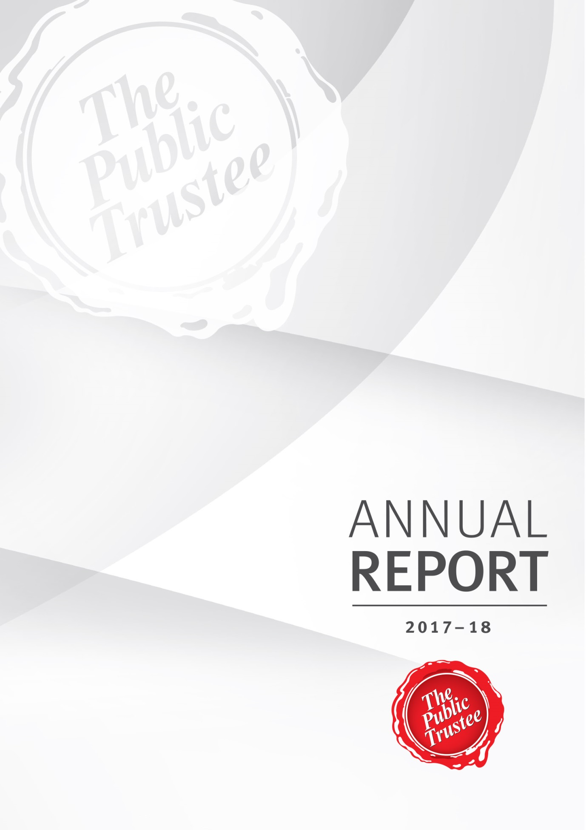

Communication objective
This annual report provides information about The Public Trustee’s financial and corporate performance for 2017–18. It has been prepared in accordance with the Financial Accountability
Act 2009.

The Public Trustee is committed to providing accessible services to Queenslanders from all culturally and linguistically diverse backgrounds. If you have difficulty in understanding this annual report, you can contact us on 1300 360 044 and we will arrange an interpreter to effectively communicate the report to you.
Copyright
© The Public Trustee of Queensland, September 2018. Published by The Public Trustee, 444 Queen Street, Brisbane QLD 4000, Australia.
Licence
This work is licensed under the Creative Commons CC BY 4.0 Australia Licence. In essence, you are free to copy and distribute this material in any format, as long as you attribute the work to the State of Queensland (The Public Trustee) and indicate if any changes have been made. To view a copy of this licence, visit https://creativecommons.org/licenses/by/4.0/.

ISSN 1839 – 1451
Attribution: The State of Queensland, The Public Trustee of Queensland
Disclaimer: While every care has been taken in preparing this publication, the State of Queensland accepts no responsibility for decisions or actions taken as a result of any data, information, statement or advice, expressed or implied, contained within. To the best of our knowledge, the content was correct at the time of publishing.
An electronic copy of The Public Trustee’s Annual Report 2017–18 is available online at www.pt.qld.gov.au. You can also contact us to request a copy by calling 1300 360 044 or emailing governance@pt.qld.gov.au
A number of annual reporting requirements are also addressed through publication of information on the Queensland Open Data website at data.qld.gov.au.

Contents
Letter of Compliance iv
From the CEO 1
Snapshot of the Public Trustee in 2017–18 3
About The Public Trustee 4
Where to find us 4
Our vision 5
Our purpose 5
Our values 6
Our legislation 6
Official Solicitor 7
Our 2017–18 achievements 8
Our strategic direction 10
The year ahead 12
Meeting challenges in our operating environment 13
Non–financial performance 14
Queensland Government objectives for the community 14
Community Service Obligations (CSOs) 15
Summary of our performance 16
Philanthropy 17
Financial performance 19
Public Trustee of Queensland Investment Fund – Growth Trust 22
Management and structure 23
Executive management 23
Senior internal management committees 26
Boards and committees with external membership 30
Public Sector Ethics 33
Public Sector Values 34
Governance – risk management and accountability 36
Governance and Risk Directorate 36
Risk management 37
External scrutiny 38
Internal audit 38
Information systems and recordkeeping 39
Governance – human resources 40
Workforce planning and performance 40
Staffing 40
Early retirement, redundancy and retrenchment 41
Our offices 42
Outreach locations 43
Glossary 45
Acronyms 47
The Public Trustee of Queensland Financial Statements 48
Public Trustee of Queensland Growth Trust Financial Statements 96
Compliance Checklist 120

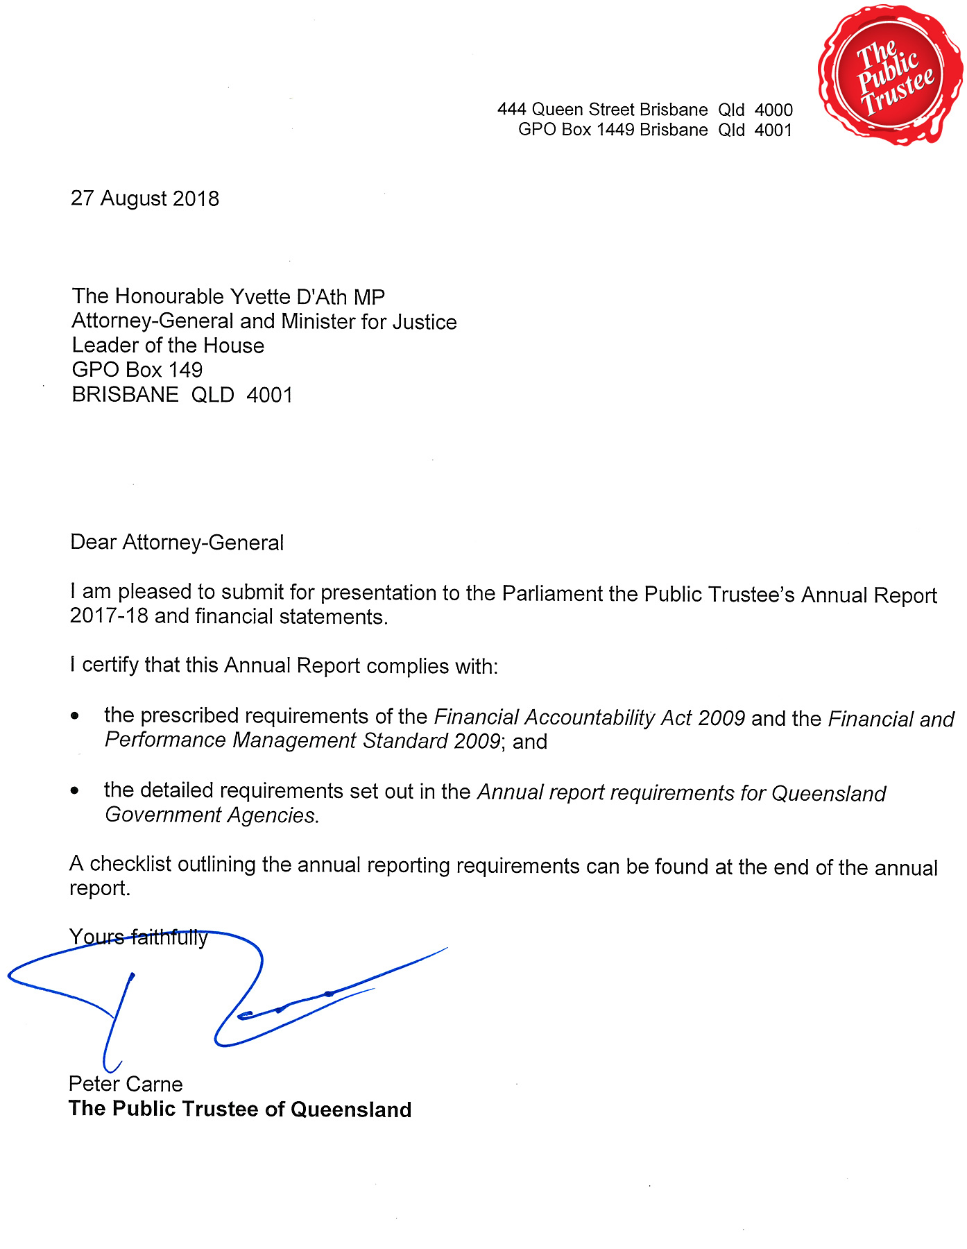
Letter of Compliance

From the CEO
This past year has been an exciting and productive time for the Public Trustee. The population of our great State has climbed to over 5 million people, and I am seeing an increasing demand for our core services. The increase is due in part to the effect of the Baby Boomer generation reaching retirement age - this generation controls much larger and more complex asset structures than any previous generation, and is expected to live longer.
These factors will continue to drive an increase in clients requiring assistance in managing their financial affairs and deceased estates to be administered. The Public Trustee is focused on delivering quality frontline services that respond to these changing client and community needs. Our Strategic Plan articulates our purpose: to lead the evolution and delivery of trustee, estate and administration services that make a positive difference in the lives of Queenslanders.
To support the delivery of these services, in 2017–18 we implemented a range of key strategic and operational initiatives which are detailed in this report. We commenced an organisation-wide business transformation to deliver organisational capability, process and technology changes aligned with our strategic objectives and to support future business needs. In particular, we have initiated digitisation projects which will deliver organisational efficiencies and sustainable improvement in business processes. Increased digital capabilities will also enhance our clients’ experience, as we make it easier, faster and more efficient for people to access our information and services whether that is online, over the phone, or in person.
Nearly half of our staff are based outside of Brisbane, and in the 2017–18 financial year we invested in upgrades to regional offices aimed at enhancing the accessibility and effectiveness of our regional and remote service delivery.
We held our annual Wills Week from 31 July to 6 August 2017, promoting awareness in the community of the importance for every Queenslander over 18 to have a valid Will. A Will is the most effective way for a person to ensure there is a smooth transfer of their assets to their relatives or other beneficiaries on their death. A large number of Queenslanders either do not have a Will or their Will does not meet their current needs or circumstances. The Public Trustee has provided a Will preparation service to the people of Queensland since 1916. This service is provided free of charge regardless of whether or not we are appointed executor of the Will. In 2017–18, we made 28,272 Wills for Queenslanders and there are now over 1 million Wills safeguarded in our state of the art Wills bunker.
In February this year, we launched our Client Service Charter – our public commitment to clients about the experience they will receive from us. I am pleased to say I see that commitment brought to life in our offices and client service centres across the State by dedicated staff supporting each other and our clients with professionalism, empathy and respect.
The Public Trustee supports some of the most vulnerable members of the community. Members of our Executive Management Team and I took part in the Vinnies CEO Sleepout in June this year, to better understand the daily struggle of thousands of Queenslanders currently experiencing homelessness. Together we raised over $14,000 which will go towards providing food, electricity and accommodation to over 116,000 people in need.
The progressive rollout of the National Disability Insurance Scheme continues to be a priority for the Public Trustee. We have worked closely with our clients, other Queensland Government agencies, the National Disability Insurance Agency and important stakeholders to ensure that all clients who are eligible for services are registered for the Scheme. Implementing a range of supports, including dedicated resources and training, we have been able to facilitate the enrolment of approximately 5,051 clients in completed regions and are currently managing registration for the final two phasing regions.
Some of the Public Trustee’s clients may also be eligible to apply for redress under the National Redress Scheme for Institutional Child Sexual Abuse, and in the coming year we will work with other agencies to determine how we may assist our clients in accessing the Scheme.
An enduring priority for the Public Trustee is to fulfil our Community Service Obligations (CSOs). We deliver a wide variety of CSOs, including:
- financial administration for adults with impaired decision-making capacity where the cost of providing that service cannot be paid for in full from the adult’s own funds
- our free Will-making service
- community education and advice to courts and tribunals in areas where we have expertise, including adults with impaired capacity, deceased estates, attorneys and enduring powers of attorney, and trust administration
- funding to the Office of the Public Guardian (which protects the rights of adults with impaired capacity)
- financial assistance under the Civil Law Legal Aid Scheme to individuals who have civil actions (mostly personal injury cases) but not sufficient funds to pay for outlays involved in advancing litigation (for example, the cost of medical reports). We partner with Legal Aid to provide the Scheme.
We provided CSOs valued at more than $35.6 M to the Queensland community in 2017–18, a demonstration of our commitment to making a positive difference in the lives of Queenslanders.
I am very proud of and thankful for the efforts of our staff, who contribute their ideas, skills and knowledge freely and openly. They are engaged, empowered and committed to putting our clients first. Led by our experienced Executive Management Team and supported by our robust governance frameworks, we are well placed to embrace the opportunities and address the challenges which will present themselves in the coming year.

Peter Carne
Chief Executive Officer and The Public Trustee of Queensland

Snapshot of the Public Trustee in 2017–18
$2.7 B  total assets  under management | $35.6 M  in CSOs at no cost  to Government | Strong operating  surplus of  $3.4 M
28,272  free Wills made | 9,811  financial management  clients | 5,051  clients registered  for the NDIS
4,540  trusts  administered | 3,477  EPA  documents made | 2,221  new deceased estates accepted for administration
584  full time  equivalent staff | Over 110,000  calls answered by the Welcome Desk | $92 M  in property sales

About The Public Trustee
The Public Trustee has been serving Queenslanders since 1916 and is governed by the Public Trustee Act 1978. The Public Trustee is self-funding and receives no financial assistance from the Queensland Government. Operating as a corporation sole, we provide financial, trustee and legal services to the people of Queensland.
In providing our services we aim to ensure:
- prudent management of the financial assets of our clients
- support for vulnerable members of the community
- an orderly succession of assets between generations
- the provision of life-planning assistance to the Queensland community by making Wills free of charge and Enduring Powers of Attorney (EPA) documents at an affordable cost.

Where to find us
We provide our services through a network of regional offices in the following locations, including our head office at 444 Queen Street, Brisbane:
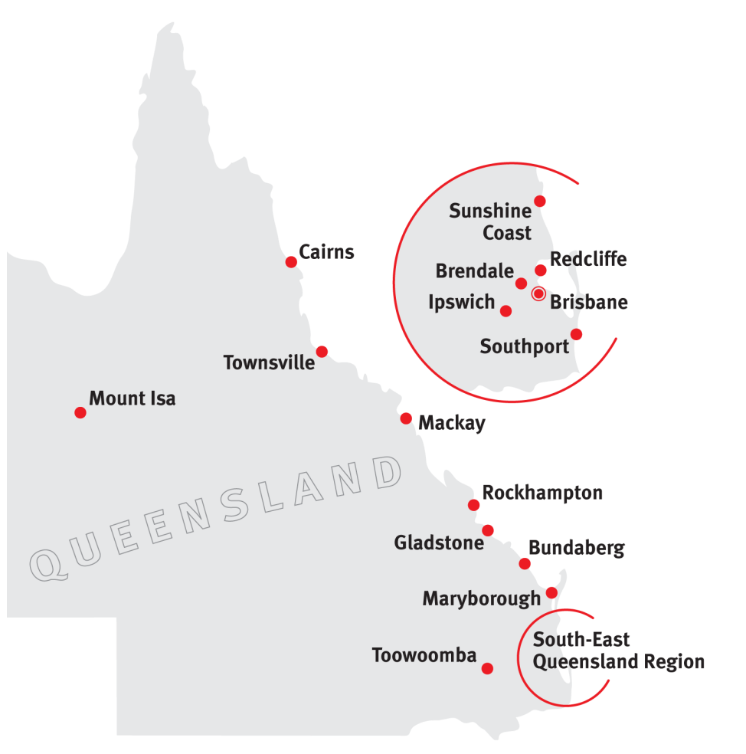
- Brendale
- Brisbane
- Bundaberg
- Cairns
- Gladstone
- Ipswich
- Mackay
- Maryborough
- Mount Isa
- Redcliffe
- Rockhampton
- Southport
- Sunshine Coast
- Toowoomba
- Townsville
We also provide services outside of the above locations through the Queensland Government Agent Program (QGAP) and the local court networks. For further information on the location of our offices or outreach locations please refer to pages 42-44 of the report. Alternatively you may also visit our website at www.pt.qld.gov.au.

Our vision
To be the independent trustee for Queenslanders providing security and peace of mind.

Our purpose
To lead the evolution and delivery of trustee, estate and administration services that make a positive difference in the lives of Queenslanders.
We provide professional and accessible:
Estate administration services
Financial management for those with impaired capacity for decision-making
Legal services
Trusts administration
Tax and investment services
Life planning services including making Wills, EPAs and Advance Health Directives
Safe and secure storage of Wills and other life planning documents
Real estate services
Philanthropy facilitation
We also:
- administer unclaimed moneys for the State of Queensland
- manage the estates of prisoners under Part 7 of the Public Trustee Act 1978
- carry out special functions of a public nature under Part 5 of the Public Trustee Act 1978
- promote and support community education on elder abuse.

Our values
On page 34, we demonstrate how
The Public Trustee is implementing
and embedding these values into all
areas of our operations.

Our legislation
The Public Trustee administers the Public Trustee Act 1978. We have a wide range of powers and functions, and operate under many other Acts including:
Acquisition of Land Act 1967
Adoption Act 2009
Agents Financial Administration Act 2014
Airports Assets (Restructuring and Disposal)
Act 2008
Associations Incorporation Act 1981
Body Corporate and Community Management
Act 1997
Building Units and Group Titles Act 1980
Charitable Funds Act 1958
Child Protection Act 1999
Child Protection (International Measures) Act 2003
Civil Partnerships Act 2011
Collections Act 1966
Companies (Acquisition of Shares) (Application of Laws) Act 1981
Corrective Services Act 2006
Criminal Proceeds Confiscation Act 2002
Debt Collectors (Field Agents and Collection Agents) Act 2014
Disposal of Uncollected Goods Act 1967
Drugs Misuse Act 1986
Financial Accountability Act 2009
Gaming Machine Act 1991
Guardianship and Administration Act 2000
Industrial Relations Act 2016
Information Privacy Act 2009
Integrated Resort Development Act 1987
Land Act 1994
Land Sales Act 1984
Legal Profession Act 2007
Liquor Act 1992
Local Government Act 2009
Local Government Electoral Act 2011
Manufactured Homes (Residential Parks)
Act 2003
Mineral Resources Act 1989
Mixed Use Development Act 1993
Motor Dealers and Chattel Auctioneers Act 2014
National Injury Insurance Scheme (Queensland) Act 2016
Personal Injuries Proceedings Act 2002
Police Powers and Responsibilities Act 2000
Powers of Attorney Act 1998
Property Law Act 1974
Property Occupations Act 2014
Public Guardian Act 2014
Public Interest Disclosure Act 2010
Public Officers Superannuation Benefits Recovery Act 1988
Public Records Act 2002
Public Sector Ethics Act 1994
Public Service Act 2008
Residential Services (Accreditation) Act 2002
Residential Tenancies and Rooming Accommodation Act 2008
Retirement Villages Act 1999
Right to Information Act 2009
Sanctuary Cove Resort Act 1985
Second-hand Dealers and Pawnbrokers Act 2003
South Bank Corporation Act 1989
Storage Liens Act 1973
Succession Act 1981
Surrogacy Act 2010
Trust Accounts Act 1973
Trustee Companies Act 1968
Trusts Act 1973
Victims of Crime Assistance Act 2009
Workers’ Compensation and Rehabilitation
Act 2003
Work Health and Safety Act 2011
Youth Justice Act 1992

Official Solicitor
The Official Solicitor is the Public Trustee’s in-house legal advisor and is appointed pursuant to section 16 of the Public Trustee Act 1978.
The Official Solicitor provides advice and conducts litigation on behalf of the Public Trustee in his many different roles. These services include:
- providing legal advice and conducting litigation in circumstances where the Public Trustee is appointed personal representative of deceased estates
- providing legal advice and conducting litigation when the Public Trustee is appointed administrator for an adult with a decision-making incapacity
- conveyancing, leasing and other property related transactions on behalf of estates under administration and the Public Trustee as a corporation sole.
The Official Solicitor has identified a number of trends in the work he undertakes on behalf of the Public Trustee, for example:
- There continues to be a large number of referrals to the Official Solicitor in relation to family provision applications, often in circumstances where the Public Trustee has been appointed as financial administrator for an adult child of a deceased person. There were 118 referrals to the Official Solicitor in the last year in relation to potential applications and 75 referrals to the Official Solicitor where the Public Trustee is administering the deceased estate. Importantly, all mediations that the Official Solicitor attended during the year involving a family provision application (whether representing the Applicant or the Respondent) resulted in a settlement.
- The Public Trustee continues to find himself appointed administrator for an adult with impaired capacity in circumstances where that adult has been the subject of financial elder abuse. The Official Solicitor offers advice on the prospects of recovery of property or money misappropriated. These are often difficult cases where the adult for whom the Public Trustee is appointed administrator (as a result of the misappropriation) is of extremely limited means to support litigation. In addition, it is often the case that the funds or property misappropriated have been dissipated by the person who has acted improperly.
- The Public Trustee has observed an increase in the number of clients with complex financial affairs. For example, clients who are company directors, often relating to corporate structures set up for the Public Trustee client’s Self-Managed Superannuation Fund.
While it is not unusual for the Public Trustee to bring an Application to the Supreme Court for the construction of a Will, in the matter of The Public Trustee of Queensland v Neary & Ors [2018] QSC 9 the Public Trustee found it necessary to identify the members of four different generations of a family and the Official Solicitor was required to serve over 100 Respondents. The Will in question referred to a gift to “all my great nieces and nephews” and the same gift to various “grand-children”. The Testator had died without issue but had many living relations. As all parties that might be affected by a Will construction had to be served, logistically this became a very large undertaking.

Our 2017–18 achievements

Driving value for clients
- $35.6 M in CSOs delivered at no cost to Government including
- fees rebated for some clients with limited assets
- 28,272 free Wills made
- public education in areas such as Wills and EPAs with an emphasis on planning for life
- funding for a range of community services through the Office of the Public Guardian and the Civil Law Legal Aid Scheme administered by Legal Aid Queensland
- financial management for 9,048 clients
- managing the estates of 512 prisoners
- acting as financial attorney for 251 clients
- managing 4,540 trusts
- making 3,477 EPAs
- accepting 2,221 new deceased estates for administration and reducing our average time to administer
- continuing to enhance frontline service delivery through:
- demonstrating our commitment to our clients through the introduction of our Client Service Charter
- introducing Express Will Appointments for clients who wish to update their existing Will with the Public Trustee
- expanding and promoting our real estate model to enhance the overall client experience for deceased estates and financial management administration services including the sale of 236 properties valued at $92 M.

Sustainable reinvestment to support business objectives
- maintaining strong financial performance which resulted in an operating surplus
of $3.4 M
- investing in capital upgrades for regional offices in recognition of our commitment to regional service delivery
- investing in digitisation projects to deliver organisational efficiencies and sustainable improvements in business processes.

Strengthening confidence and value in our services
- strengthening relationships with a wide variety of stakeholders including other agencies and community groups, including:
- hosting our annual Queensland Wills Week to promote the importance of every Queenslander over the age of 18 having an up to date Will
- collaborating with the Department of Communities, Disability Services and Seniors, the Office of the Public Guardian and members of the community to promote and participate in elder abuse awareness activities
- establishing a partnership with the JPs in the Community Program, an initiative of the Justices of the Peace Branch, Department of Justice and Attorney-General. The partnership aims to educate Justices of the Peace (JPs) about life planning and estate administration. We provide JPs with current information regarding the witnessing of Wills and EPA documents, and are available to respond to enquiries generated by the general public as they engage with the Program
- continuing to support philanthropic endeavours through the financial management of charitable and philanthropic trusts.

Targeted and effective service delivery
- supporting Public Trustee clients who are eligible for the National Disability Insurance Scheme, and ensuring all eligible clients are registered for the Scheme
- redesigning our client surveys to better measure service effectiveness and client satisfaction for administration of deceased estates, financial management, trusts administration, and Wills and EPA services (results are available on page 16)
- fostering expertise in service delivery through operating five Centres of Excellence (Testamentary Trusts, Minors Trusts, Group Housing, Residential Care and Advanced Residential Care)
- focusing, through our Centres of Excellence, on improved communication, faster and more consistent responses to client enquiries, streamlined processes and building a specialist knowledge base.

Engaging and empowering our workforce
- Engaging and empowering our workforce through:
- coordinating a Recognition of Prior Learning program for all employees who have completed the Level 1 and 2 Technical Training programs to date. This program has enabled 16 eligible employees to achieve a nationally recognised qualification (Certificate IV in Personal Trust Administration)
- delivering a Wills and Enduring Power of Attorney Accreditation Program
- a Leadership and Management Development Program for 27 employees, delivered by the Queensland University of Technology (QUT) and aimed at developing the capability and competency of middle managers
- technical training Level 1 for 25 frontline service delivery employees, focusing on foundational skills for entry level officers
- technical training Level 2 for 39 employees, focused on complex skills for
frontline staff
- embedding the Queensland Public Service values across the Public Trustee through culture workshops for all employees, including values initiatives such as Values In Action and Confident Customer Conversations.
The progressive rollout of the National Disability Insurance Scheme (NDIS) continues to be an area of focus for our organisation, and our NDIS Program was pivotal in 2017–18. This scheme aims to provide about 90,000 Queenslanders under the age of 65 with a permanent and significant disability with the reasonable and necessary supports they need to live an ordinary life. For clients where we are appointed financial administrator for adults with a decision-making incapacity, our emphasis is to ensure they have access to the Scheme.
We have invested considerable effort in communicating with our client base to ensure they are aware of the Scheme, and are progressed towards registering for it. The Public Trustee understands the importance of stakeholder engagement – in particular, engagement with the National Disability Insurance Agency (NDIA). We initiated, and continue to host, the Justices’ NDIS Interest Group Meeting of the Justice and Human Rights Agencies (Qld). We also actively engage with the Queensland Directorate of the NDIA (Scheme Implementation), the NDIS Whole of Government Scheme Implementation Regional Programs and the NDIS Project Management Office.
By the time Queensland’s NDIS phasing-in is complete in 2019, we will have reviewed approximately 9,000 financial management clients to determine their eligibility for the Scheme. This equates to approximately 6,000 NDIS eligible clients.
During 2017, NDIS registration rollout for our clients was completed for:
- Townsville, Hinchinbrook, Burdekin, west to Mt Isa, and up to the gulf
- Mackay, Isaac and Whitsundays
- Toowoomba and west to the borders
- Ipswich, Lockyer, Scenic Rim and Somerset
- Bundaberg
- Rockhampton, Gladstone and west to the borders.
In 2018, NDIS registration rollout for our clients was completed for:
• Cairns • Brisbane • Redcliffe
• Maryborough • Southport • Ipswich
• Toowoomba.
Approximately 5,051 clients from Townsville, Mackay, Toowoomba, Ipswich, Bundaberg, Rockhampton, Logan and Redlands, Cairns, Brisbane and Fraser Coast regions have been registered for the Scheme. We are currently managing registration of the Moreton Bay and Sunshine Coast cohort (the final two phasing regions), which will see approximately 826 additional clients registered.

Our strategic direction
Our strategic direction is documented in our Strategic Plan, which can be accessed on our website. The Strategic Plan sets the parameters for our strategic direction to staff, clients and stakeholders. It also outlines how we will contribute to the achievement of the Queensland Government’s objectives for the community, our priorities and our strategies. It also includes performance indicators determining how our objectives will be measured.
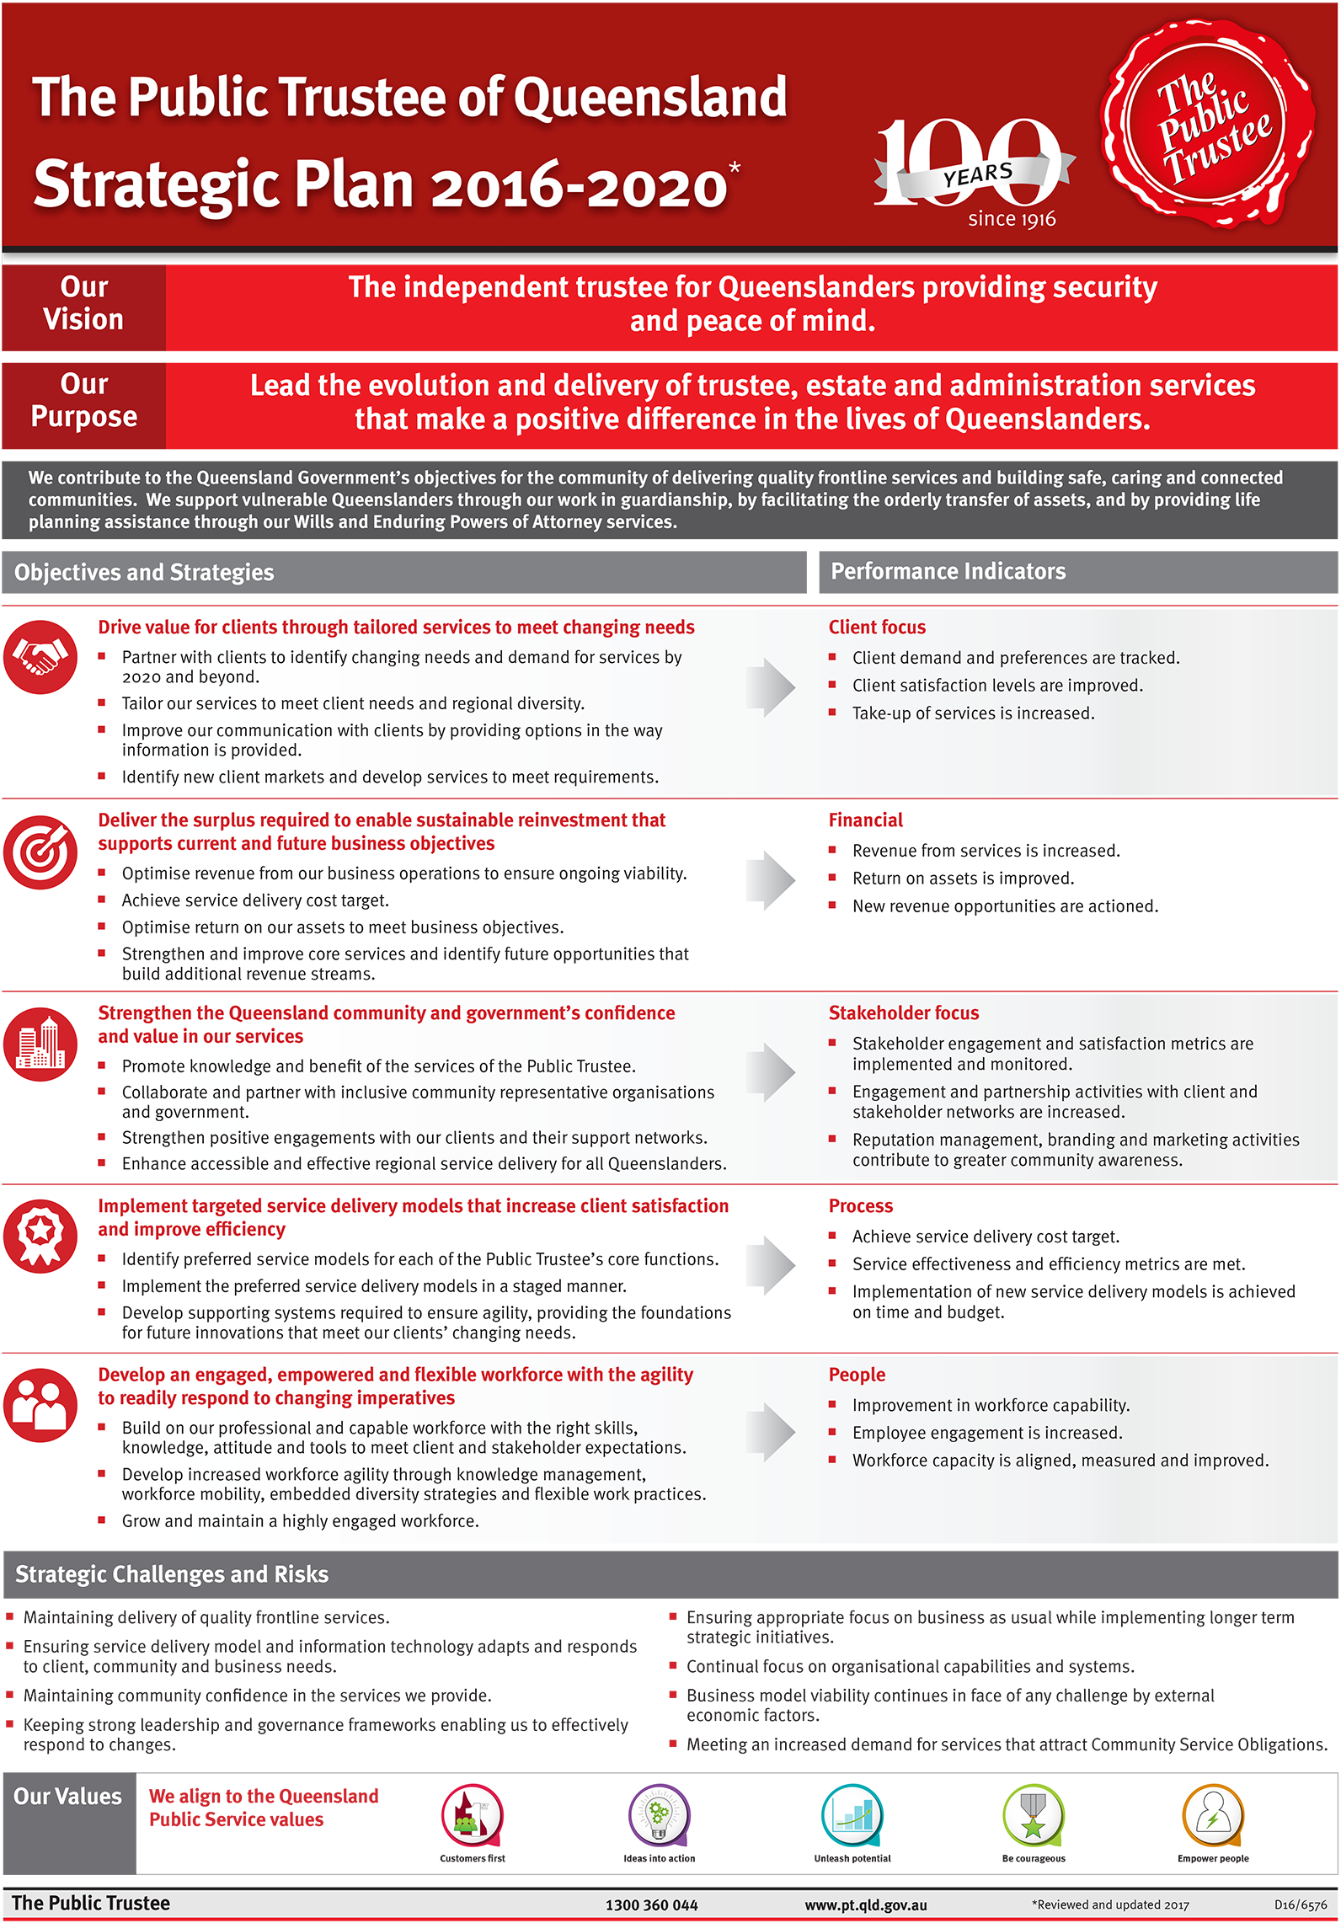

The year ahead
To support our strategies, our key priority for 2018–19 is our business transformation initiative to deliver organisational capability, process and technology changes aligned with our strategic objectives and to support future business needs.
The proposed business transformation will enable us to deliver the following strategic objectives:
 | Drive value for clients through tailored services to meet changing needs |  |  | Implement targeted service delivery models that increase client satisfaction and improve efficiency |  |  | Strengthen the Queensland  community and government’s confidence and  value in our services
The organisation-wide initiative will include replacing the Public Trustee’s core client information system, with a new system to provide a foundation for future innovation and to support our clients’ changing needs, establishing information system platforms to facilitate an enhanced client experience (for example, website enhancements including portals providing clients with access to view and manage their information online) and digitisation projects which will deliver organisational efficiencies and sustainable improvement in business processes including records digitisation.
Additional key priorities for 2018–19 include:
- providing ongoing financial management for Queenslanders with impaired financial decision-making capacity
- ensuring strong leadership and governance frameworks to enable us to effectively respond to challenges
- investing in upgrading facilities at regional offices to better service clients
- enhancing frontline service delivery in response to client satisfaction survey outcomes
- continuing to enhance our organisational capability through investment in people and systems.
We are committed to providing efficient, quality services to our clients. We continue to redevelop regional offices to improve frontline service delivery, efficiency and accessibility for all clients, as well as continuing to maintain appropriate work health and safety standards for clients and staff.
During 2018–19 capital expenditure is estimated to be $21.6 M comprised of:
$13.3 M
Business transformation program
$6.7 M
Building improvements
$1.6 M
Plant and equipment

Meeting challenges in our operating environment
Through our strategic planning, we have identified a number of key risks to achieving our vision and purpose. Increasing demand for services that support vulnerable Queenslanders and attract CSOs impacts our ability to fund service delivery at no cost to Government. We must also maintain community confidence and trust in the services we provide. Changing economic factors, government priorities and customer expectations could adversely affect the viability of our business model. Undertaking environmental scanning to ensure we focus appropriately on business as usual while also implementing longer term strategic initiatives is important.
The challenges posed by these risks present the Public Trustee with the opportunity to:
- deliver quality frontline services that respond to changing client and community needs
- implement new technologies and harness the benefits to be innovative and competitive in our service delivery
- ensure our leadership and governance frameworks enable us to effectively respond to challenges
- actively engage with government and other stakeholders to advocate for positive outcomes for our clients and the community
- implement incremental innovations to deliver improvements to customer and stakeholder experiences
- continue to enhance our organisational capability through investment in people and systems.

Non–financial performance
We contribute to the Queensland Government’s objectives for the community of delivering quality frontline services and building safe, caring and connected communities. We provide life planning assistance and facilitate the orderly transfer of assets through our Wills and Enduring Powers of Attorney (EPA) making service, and support vulnerable Queenslanders through our work in financial administration.
For more information about our objectives, please see our Strategic Plan at: www.pt.qld.gov.au.

Queensland Government objectives for the community
The Public Trustee’s strategic objectives are aligned with the Queensland Government’s objectives for the community. We particularly contributed to two of those objectives as demonstrated below.
Delivering quality frontline services | In 2017–18, we:  - delivered $35.6 M in CSOs at no cost to the Queensland Government including:  - fees rebated for some clients with limited assets  - providing a free Will making service  - public education in areas such as Wills and EPAs with an emphasis on planning for life  - made 28,272 Wills and 3,477 EPAs  - provided financial administration services for 9,048 adults with impaired decision-making capacity and acted as financial attorney for 251 people  - undertook an ongoing review of service delivery models and locations to better meet growing and changing demographic needs of Queenslanders  - continued to support philanthropic endeavours through the management of philanthropic and charitable trusts (see page 17 for more information).
Building safe,  caring and  connected communities | In 2017–18, we:  - supported a range of community services through the Office of the Public Guardian and funding the Civil Law Legal Aid Scheme administered by Legal Aid Queensland  - continued to contribute funding to the Department of Communities, Child Safety and Seniors’ No excuse for elder abuse campaign  - maintained our Will making outreach services to ensure more Queenslanders can access our services  - provided extensive community education around the importance of having a valid Will and EPA.
Looking to the future, the Public Trustee will continue its focus on utilising advancing technology and digitisation of services to make it faster and more efficient for Queenslanders to access our information and services. In 2018–19, we will demonstrate our commitment to Our Future State: Advancing Queensland’s Priorities and the Queensland Government’s objective to be a responsive Government.

Community Service Obligations (CSOs)
A range of CSOs were provided in 2017–18 including:
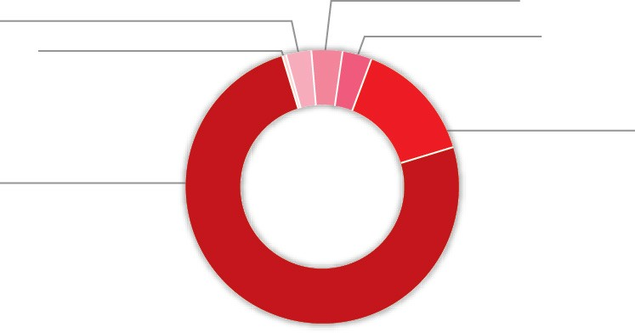
$1.0 M
Public community education and advice to the courts and tribunals in the areas in
which the Public Trustee has expertise
$1.2 M
A cash contribution to the Office of the Public Guardian
$1.2 M Other
$0.4 M
Civil Law Legal Aid - outlays written-off and administrative support
support
$26.7 M
Fees rebated for clients with limited assets
$5.1 M
Provision of a free Will making service to Queenslanders
The total cost of CSOs delivered for the 2017–18 financial year was $35.6 M representing an increase of 5.5 per cent from the previous financial year (which was $33.8 M). An amount of $37.7 M is budgeted for 2018–19.
Category of CSOs | 2017–18  Actual | 2018–19  Budget
Fees rebated for clients with limited assets | $26,693,526 | $28,441,448
Fees rebated for principal residence and other | $1,159,983 | $736,455
Management of estates of prisoners | $138,934 | $455,228
Public community education and advice to the courts and tribunals in the areas in which the Public Trustee has expertise | $952,669 | $1,288,521
Providing a free Will making service to Queenslanders | $5,088,960 | $5,264,175
Cash contribution to the Office of the Public Guardian | $1,152,000 | $1,144,000
Civil Law Legal Aid - outlays written-off and administrative support | $435,792 | $373,164
Total | $35,621,864 | $37,702,991

CSOs are reported in our Financial Statements in two areas:
- deduction from fee revenue ($34.0 M 2017–18) where there is a rebate of fees or services provided at no charge
- expenditure ($1.6 M 2017–18) as contributions towards other sector operations.

Summary of our performance
Client Experience and Delivery is the frontline interface with our clients and the community, providing:
- deceased estate administration - the Public Trustee administers deceased estates pursuant to Wills or on intestacy, delivering quality services to beneficiaries
- financial management - the Public Trustee acts as administrator for financial matters for clients with impaired capacity for decision-making pursuant to the Guardianship and Administration Act 2000 or as a financial attorney pursuant to the Powers of Attorney Act 1998
- a Will making service - the Public Trustee prepares Wills free of charge for all Queenslanders.
We measure our performance across the Client Experience and Delivery service area using three effectiveness measures and one efficiency measure.
The table below summarises our performance (quantifiable measures and qualitative achievements) against performance indicators in the Public Trustee’s Service Delivery Statement 2017–18 and those in our Strategic Plan 2016–2020. Our objective is to deliver a full range of professional, accessible and reliable personal trustee, financial and related services that meet client needs.
Service area: Client Experience and Delivery¹ | Notes | 2017–18  Target/  Estimate | 2017–18  Actual | 2018–19  Target/  Estimate
Service standards  Effectiveness measure  Overall client satisfaction with the deceased estate administration service as measured by client  satisfaction index | 2 | 70% | 66% | 70%
Overall client satisfaction with financial management service as measured by client satisfaction index | 3 | 70% | 70% | 70%
Overall client satisfaction with Will preparation services | 4 | 90% | 98% | 90%
Efficiency measure  Cost per Will | 5 | $198 | $180 | $180
- This service area was previously comprised of three material services: deceased estate administration, financial management, and Will making. Services have been consolidated to better reflect materiality.
- The satisfaction index is calculated by an independent market research provider on an annual basis. The index is calculated by summing 50% of the overall satisfaction score and 50% of a score derived from service and process factors which have been weighted according to importance and combined to provide a single score.
- The satisfaction index is calculated by an independent market research provider on an annual basis. The index is calculated by summing 50% of the overall satisfaction score and 50% of a score derived from service and process factors which have been weighted according to importance and combined to provide a single score.
- All clients preparing a Will with the Public Trustee receive a Wills Questionnaire. The Wills Questionnaire contains eight questions relating to the quality and delivery of the Will making service provided. The overall satisfaction level is calculated as a percentage of positive responses to total number of responses received.
- This measure is calculated using the total cost of making free Wills divided by the number of Wills drafted and completed in the financial year.
Since 2013, the Public Trustee has conducted a client satisfaction survey specifically with beneficiaries of deceased estates at completion of administration, and with clients (and their carers) for whom the Public Trustee acts as a financial manager. The overall objective of the research is to gain understanding and insights into client experiences and the administration process.
The results of this research are highly valued and have been used to develop and implement a range of operational improvements including communication and supervision strategies, and enhanced financial management and deceased estate processes. The main aim of these changes is to improve the client experience and our service delivery.
Applying a service logic approach and reflecting better practice aligned with contemporary industry standards, in 2017–18 we redesigned our research. The changed methodology includes measuring satisfaction using an 11 point scale rather than the previous 7 point scale. As a result, our effectiveness and efficiency measures remain articulated in the same way but some of our estimated actual results vary slightly from those reported in our Performance Statement (published in the Service Delivery Statement as part of our 2018–19 Budget Papers). Direct comparisons between previous results and the 2017–18 results are not possible. However, the benefits we will derive from our changed methodology in future years far outweigh these minor points.
Looking to the future, we will use the insights and information obtained through this research when implementing targeted service delivery models that increase client satisfaction and improve efficiency.

Philanthropy
The Public Trustee is trustee for the following leading philanthropic charitable trusts in Queensland.
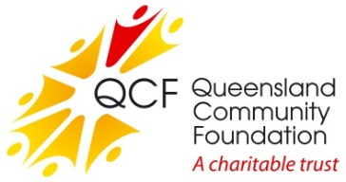
Queensland Community Foundation
The Queensland Community Foundation (QCF) was established in 1997 to provide a permanent source of philanthropic funding for charitable organisations to enable them to respond to the needs of the Queensland community.
The QCF continued to grow in 2017–18 and now has funds under management close to $87.2 M. During the year, QCF paid distributions to a broad range of charities in excess of $2.5 M.
For further information, visit www.qcf.org.au.
QCF Sub Fund: Gulf Area Community Social Development
Established under the umbrella of the QCF in 2000, this sub fund has assets close to $6.6 M.
The sub fund supports the Gulf Area Community by providing grants to projects and initiatives that encourage educational, health, cultural and social development.

Queensland Aboriginal and Torres Strait Islander Foundation
The foundation was established in 2008 and provides a secure, independent and perpetual funding source to advance the education of Aboriginal and Torres Strait Islander children and young people in Queensland through provision and promotion of scholarships.
The trust has net assets close to $40.4 M.
Scholarships of more than $1.6 M for 1,051 Indigenous students from 225 Queensland high schools were approved in 2017–18. In total, 7,305 students have been approved for scholarships since the foundation commenced in 2008.
For further information, visit www.qatsif.org.au.
Lady Bowen Trust
Established in 2006, the trust aims to re-engage people experiencing chronic homelessness so they achieve genuine, positive and lasting outcomes. The trust supports Mission Australia which maintains Roma House, a facility to enhance clients’ life skills, confidence and resilience while assisting them to find secure accommodation.
The trust has net assets of approximately $5.2 M with distributions totalling close to $200,000 in 2017–18.
For further information, visit www.ladybowentrust.org.au.
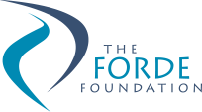
Forde Foundation
The Forde Foundation was established in August 2000 in response to the findings of the Commission of Inquiry into Abuse of Children in Queensland Institutions, better known as the Forde Inquiry. The foundation is designed to support former residents of Queensland institutions. Financial support is provided to individuals for specific purposes such as dental care, education, training and personal development opportunities.
The foundation has net assets of approximately $4.1 M with distributions totalling close to $140,000 in 2017–18.
For further information, visit www.fordefoundation.org.au.
Gladstone Foundation
Established in early 2011, the foundation allows for industry funds to be channelled into this perpetual trust to provide social infrastructure and service needs in the Gladstone Region.
Specific purposes of the trust are relieving poverty, assisting the aged, relieving sickness or distress, advancing religion and education, providing child care services on a non-profit basis and other purposes which benefit the Gladstone Region.
Initial capital received by the trust was $13.5 M. The foundation has net assets of approximately $7.4 M as at 30 June 2018, with distributions totalling $1.2 M paid in 2017–18.
For further information visit www.gladstonefoundation.org.au.

Financial performance
The Public Trustee’s Financial Statements are included from page 48.
The Public Trustee has achieved a sound financial result for 2017–18 recording an operating surplus of $3.4 M. The financial performance benefited from higher than anticipated fee revenue and savings in employee expenses, although partially offset by higher agency staff costs included in Supplies and Services.
A summary of our revenue and expenditure over the last seven financial years is as follows:
Revenue & Expenses
Our revenue sources in the last two financial years comprise the following:

Revenue sources | 2016–17 | 2017–18
Fees and Charges | 63% | 65%
Interest Revenue | 33% | 31%
Other Revenue | 4% | 4%
Total Revenue | 100% | 100%
Gross revenue from fees and charges increased by 7.1 per cent from the previous year. The majority of CSOs are deducted from gross fees to arrive at net fees and charges reported in the financial statements, with the remaining CSOs amount recorded in contributions expense. This year, we provided a total of $35.6 M in CSOs at no cost to the Queensland Government, which was a 5.5 per cent increase from the previous year. The main driver of the increase in CSOs was a 5.4 per cent increase in fees rebated for clients with limited assets. As the Public Trustee is self-funded, these obligations were met from our own sourced revenue. Interest revenue was lower than the previous year due to a lower interest rate environment.

Our expenditure in the last two financial years comprises the following:

Expenditure | 2016–17 | 2017–18
Employee Expenses | 58% | 60%
Supplies and Services | 22% | 20%
Interest Expense | 14% | 13%
Depreciation and Amortisation | 2% | 3%
Contributions | 2% | 2%
Other Expenses | 2% | 2%
Total Expenditure | 100% | 100%
Total expenses increased 1.9 per cent from the previous year. Non-employee expenses decreased by 3 per cent due to lower supplies and services in comparison to the previous year. The decrease in supplies and services expenditure is predominantly due to lower agency costs as a result of fewer vacant positions, slightly offset by higher computer expenses.
Employee expenses increased as a result of a higher number of full-time equivalent (FTE) staff coupled with a 2.5 per cent increase in staff salaries in the 2017–18 year.

Other Comprehensive Income
The Public Trustee holds interests in financial assets and various land and buildings located throughout the state from which our offices operate. These assets are recorded at fair value and are revalued periodically in accordance with Australian Accounting Standards. The gains and losses that result from these revaluations are recorded as other comprehensive income in the statement of comprehensive income.
In June 2018, building values were updated using indices provided by State Valuation Services that were derived from observable inputs such as market data and publicly available information on market transactions resulting in a $0.6 M increase in the asset revaluation surplus.
The market value of the Public Trustee’s financial assets recorded unrealised losses of $1.2 M due to an increase in bond yields in 2017–18. These factors resulted in a total other comprehensive loss of $0.6 M for 2017–18, which combined with the operating surplus, resulted in total comprehensive income of $2.8 M for 2017–18.

Statement of Financial Position

Total Assets
Total assets comprise:
- cash
- financial instruments (mainly short to medium term investments)
- property, plant and equipment.
As at 30 June 2018, the Public Trustee held $955 M in assets, an increase of $5.1 M from
30 June 2017, mainly due to a larger investment portfolio compared to the prior year.

Total Liabilities
The Public Trustee’s liabilities include amounts held for clients, amounts owing to staff for leave entitlements and amounts owed to suppliers. Total liabilities were $753 M as at 30 June 2018, an increase of $2.3 M on the previous year. The increase in liabilities is primarily due to an increase in amounts held on behalf of clients.

Statement of Changes in Common Fund Reserves
Total Common Fund reserves were $202 M as at 30 June 2018, which is slightly higher than the prior year. Common Fund reserves are operating surpluses achieved during the previous financial years.
A summary of our assets and liabilities over the last seven financial years is as follows:
Assets & Liabilities
Prospective Outlook
A budgetary deficit is forecast for the 2018–19 financial year due to the funding of the business transformation project. A balanced budget position is forecast (excluding the business transformation project).

Chief Finance Officer Statement
Our Chief Finance Officer (CFO) has fulfilled the responsibility as required by the Financial Administration Act 2009. The CFO has provided The Public Trustee of Queensland with a statement about financial controls, in accordance with section 57 of the Financial and Performance Management Standard 2009. This statement was noted by the Audit and Risk Management Committee (ARMC).

Public Trustee of Queensland Investment Fund – Growth Trust
The Public Trustee of Queensland Growth Trust (Growth Trust) was established to provide our clients with the opportunity to have their funds managed by the Public Trustee with the expert assistance of a professional investment manager.
The Public Trustee is the manager and trustee of the Growth Trust and is responsible for determining the investment objectives and strategy, arranging for the proper investment of all monies and ensuring the appointed investment manager achieves acceptable rates of return. The Public Trustee has appointed QIC Limited ACN 130 539 123 (QIC) as the investment manager of the Growth Trust.
The investment aim and objective of the Growth Trust is to provide a fully diversified investment strategy for those seeking long-term income and capital growth. The investment objective of the Growth Trust is to generate average returns (net of fees and costs) of CPI + 2.4% p.a. over rolling five year periods.
The Growth Trust currently gains exposure to various assets classes and investment sectors by investing in the QIC Growth Fund, while liquidity for the Growth Trust is managed by an investment of approximately one per cent in the QIC Cash Enhanced Fund.
The asset allocation strategy of the Growth Trust is managed within the QIC Growth Fund, a diversified portfolio of assets including Australian and international shares, fixed interest, property, infrastructure, private equity, alternative assets and cash.
The investment objective of the Growth Trust and performance for the five year period ending 30 June 2018 is as follows:
Fund | CPI Objective  (after fees) | Objective  Target Return (%) | Annualised  Return (%)
Growth Trust | CPI + 2.4% over rolling 5 years | 3.94% | 6.98%
Further information on the Growth Trust is available in its Product Information Statement and additional information is available on our website at http://www.pt.qld.gov.au/about/publications/investments/.

Management and structure

Executive management
Experience and performance
The Executive Management Team provides the necessary leadership for the Public Trustee to achieve its strategic direction and goals, led by The Public Trustee of Queensland and drawing on the expertise of others when required.
Peter Carne
The Public Trustee of Queensland
Peter Carne brings over 30 years legal expertise to his statutory appointment as The Public Trustee of Queensland, a role he held from 2009 to 2014 and holds currently after being re-appointed in 2016. In addition to managing his own legal practice, Peter has held a number of public roles including Chief Executive Officer of the Queensland Law Society, Commissioner of the Queensland Legal Aid Commission and Director of the College of Law (Queensland). He has also held a number of honorary positions including President of the Queensland Law Society, Chair of the Queensland Law Society Specialist Accreditation Board and Director of the Queensland Law Foundation.
In 2003, Peter was awarded the Centenary Medal for his contribution to the legal profession. He has a Bachelor of Arts and a Bachelor of Laws from the University of Queensland and is a Fellow of the Australian Institute of Company Directors. In 2017, he was presented with life membership of the Queensland Law Society.
From 1999 until 2007 he was a board member of Tarong Energy Corporation and was a board member of Australia Post from 2009 to 2015, chairing the Audit and Risk Committee.
Peter graduated with an Executive Graduate Certificate in Business (Leadership through Coaching and Mentoring) with the QUT Business School in 2017. He is now undertaking an Executive MBA through the QUT Business School.
Peter is committed to ensuring the future sustainability of Queensland’s Public Trustee and achieving the vision to be the independent trustee for Queenslanders providing security and peace of mind.
Mark Crofton
Deputy Public Trustee and Official Solicitor
Mark Crofton is the Deputy Public Trustee and Official Solicitor. In the latter role Mark heads the Office of the Official Solicitor, providing in-house legal advice to The Public Trustee of Queensland in his many and varied capacities.
Mark has a Bachelor of Arts and a Bachelor of Laws (Hons) from the University of Queensland and a Masters of Laws from QUT. He was a 2011 Churchill Fellow. Mark has extensive experience practising law in both the private and public sectors and has spent a large part of his career undertaking legal work in relation to succession, trusts and clients with a disability.

Amanda MacDougall
Executive Director, Client Experience & Delivery
Amanda MacDougall commenced with the Public Trustee in May 2017 as Executive Director, Client Experience & Delivery. In this role, Amanda is responsible for the customer experience across all product and service lines including regional service delivery, channel strategy and business growth via new business and product development. Her career spans 20 years, 15 of which have been in senior management roles leading large multi-disciplinary teams including operations, customer service, customer loyalty programs, sales, marketing, business development and general management across a diverse range of industries such as mining, banking, public sector and, most recently, financial services.
Amanda is committed to delivering robust commercial outcomes through an unrelenting focus on the customer, galvanising teams to execute the Strategic Plan. Her key focus is to lead the strategic change program to invigorate the customer experience across all product and service lines for the Public Trustee. Amanda has completed various business studies including the Company Director’s CourseTM with the Australian Institute of Company Directors.
Justine Callaghan
Executive Director, Investment & Finance Services & CFO
Justine Callaghan was appointed in February 2018 as the Executive Director, Investment & Finance Services & CFO. Justine is responsible for the financial management and investment frameworks of the Public Trustee. Prior to this appointment, Justine was the Acting Executive Director, Investment & Finance Services & CFO from June 2017; her former role within the Public Trustee was the Director Finance from October 2015. Justine has extensive experience in senior finance leadership roles predominantly in the mining industry, in particular with Glencore (formally Xstrata and Mount Isa Mines Limited).
Justine has a Bachelor of Commerce (majoring in Accounting) from the University of Southern Queensland and is a Certified Practising Accountant. Justine is a graduate of the Australian Institute of Company Directors’ Company Directors CourseTM.
David Cook
Executive Director, Digital & Technology
David Cook commenced as the Executive Director, Digital & Technology in April 2017 and is accountable for Digital Business and Technology Strategy, Enterprise Change, Information Systems and Records Management for the Public Trustee. His career has included roles leading operations, strategy, customer service, account management, security/business resilience, continuous improvement, consultancy, merger and acquisition and commercial management across defence, retail, high technology, resources and financial services.
David has a Bachelor of Business (Dist), an MBA (Dist) and has undertaken training in Digital Design, Behavioural Finance, Negotiation, Six Sigma, Lean, Total Quality Management, Risk Management, Sales Systems and Technology Governance. David is a graduate member of the Australian Institute of Company Directors and is an experienced not-for-profit Director and Chair.

Erica Gallagher
Senior Director, Human Resource Services
Erica Gallagher commenced in January 2016 as the Director Human Resources. Erica’s role was later changed to Senior Director, Human Resources & MarComms when the executive management structure was reviewed in 2016. Erica’s career spans over 30 years, 15 of which have been in senior leadership roles. Erica has worked in government and the not-for-profit disability sector in Western Australia. Erica is committed to contemporary human resource practice and the enhancement of the human resource profession by focusing on employee engagement, organisational culture, diversity of perspective, capability enhancement, performance development and managing the complexity of the workforce in a global environment of digitalisation and intergenerational challenges.
Erica was the Australian Human Resources Institute (AHRI) Western Australia State President and is currently a Councillor on the AHRI Queensland Council.
Josephine Giles
Senior Director, Governance & Risk
Josephine commenced as Senior Director, Governance & Risk in May 2017. In this position, Josephine is responsible for leading all governance and related functions for the Public Trustee, including government relations, statutory reporting, risk management, complaints management, fraud and corruption control, business continuity planning, information privacy, right to information and administrative access and release. Josephine has extensive experience across Queensland Government agencies including Queensland Health, Queensland Treasury and the Department of the Premier and Cabinet.
Josephine has a Bachelor of Commerce (majoring in Accounting and Finance) and a Graduate Certificate in Policy Analysis from Griffith University. She is a graduate member of the Australian Institute of Company Directors.
Elissa Pearse
Senior Director, Office of the Chief Executive Officer
Elissa commenced as Senior Director, Office of the CEO following a period of service as Director Strategy and Risk. Elissa works closely with The Public Trustee of Queensland and the Executive Management Team on strategy and business planning, and provides secretariat support to
the ARMC.
Elissa has a Bachelor of Business (majoring in Banking and Finance) and a Bachelor of Laws (Hons) from QUT and a Graduate Diploma in Legal Practice from the College of Law, Sydney. She has over 10 years’ experience in the financial services industry in the United Kingdom and Australia.
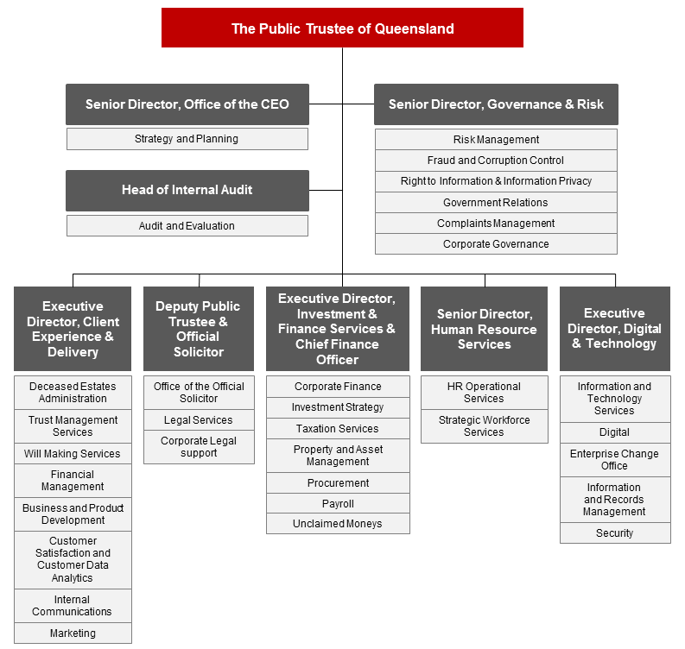

Senior internal management committees
The Public Trustee has established a range of internal committees to support all areas of operation. The committees have varying roles and functions and are established for specific purposes either because of a legislative imperative or in response to the needs of the organisation.
Internal committees play an important role in helping to meet compliance obligations.
These committees are an integral part of our governance arrangements that also include performance reporting and internal and external conformance to ensure that better practice and standards are applied and adhered to in all areas of our operations.

Executive Management Team
The EMT is the senior leadership team for the Public Trustee. The purpose of the EMT is to:
- support The Public Trustee of Queensland in meeting the responsibilities outlined in the Public Trustee Act 1978 and other relevant legislation
- provide leadership, direction and guidance to ensure that the Public Trustee provides quality trustee, estate and financial administration services to the people and Government of Queensland.
The EMT undertakes the following functions:
- determining the Public Trustee’s vision, purpose, and strategic objectives
- developing and monitoring implementation of strategic initiatives
- making recommendations to the Public Trustee in relation to strategic planning, policy setting, budget and resource allocation
- identifying strategies and building organisational capability to the future sustainability of the Public Trustee
- promoting a risk management culture and committing to organisational risk management principles including assessing the material business and strategic risks facing the organisation
- ensuring the:
- efficient, effective and equitable use of current and future Information and Communication Technology (ICT) resources
- contribution towards business direction at an agency, cross-agency, government and cross-jurisdictional level.
Membership of the EMT is determined by The Public Trustee of Queensland. The members as at 30 June 2018 were:
- The Public Trustee of Queensland (Chair)  - Deputy Public Trustee and Official Solicitor  - Executive Director, Client Experience  & Delivery  - Executive Director, Investment & Finance Services & CFO | - Executive Director, Digital & Technology  - Senior Director, Human Resource Services  - Senior Director, Office of the CEO  - Senior Director, Governance & Risk.
The EMT met 27 times during 2017–18.

Organisational Performance Group
The role of the Organisational Performance Group (OPG) is to provide a forum to share information across the Public Trustee through:
- overseeing the implementation of the Public Trustee’s operational and specific purpose plans developed to support the Strategic Plan
- monitoring ongoing organisational performance.
The core functions of the OPG are to:
- monitor and review organisational performance against delivery of existing priorities, operational and specific purpose plans
- monitor organisational performance against key metrics
- ensure appropriate action is being taken where necessary to address any performance issues
- share information in relation to future developments that may impact strategic direction including policy changes, technological developments, research activities and legislative and regulatory requirements.

Membership of the OPG is determined by The Public Trustee of Queensland. The members as at 30 June 2018 were:
- The Public Trustee of Queensland (Chair)  - Deputy Public Trustee and Official Solicitor  - Executive Director, Client Experience  & Delivery  - Executive Director, Investment & Finance Services & CFO  - Executive Director, Digital & Technology  - Senior Director, Human Resource Services  - Senior Director, Office of the CEO  - Senior Director, Governance & Risk  - Director, Finance  - Director, Investment & Taxation Services | - Director, Property  - Director, Estates & Trusts  - Director, Disability Services  - Director, Regional Services  - Director, Client Experience  - Deputy Official Solicitor  - Director, Legal Services  - Chief Information Officer  - Manager, Marketing & Communication  - Head of Internal Audit.
OPG met 12 times during 2017–18.

Workplace Health and Safety Committee
The Public Trustee has a Workplace Health and Safety (WH&S) Committee to ensure compliance with the Work Health and Safety Act 2011.
Members of the committee are:
- Senior Director, Human Resource Services (Chair)  - Manager, HR Operational Services  - Senior Coordinator, WH&S & Injury Management  - Coordinator, WH&S & Injury Management | - Property Manager  - Health and Safety Representatives (HSRs) from each regional location and one from each floor in the Brisbane office  - Regional Managers (where the regional office has not nominated a HSR).
The committee met four times during 2017–18.

Establishment Review Committee
As a result of a review and streamlining of the Public Trustee Human Resource Delegations in December 2017 and updates in vacancy approval processes, the Establishment Review Committee was disbanded in December 2017.

Agency Consultative Committee
The key objective of the Agency Consultative Committee (ACC) is to provide a mechanism for management and Union delegates to identify, raise and discuss current or emerging issues such as workload management, organisational change, training and development and other related matters.
The ACC core membership includes:
- a Union Organiser  - three Union Delegates  - Senior Director, Human Resource Services (Chair)  - Executive Director, Client Experience  & Delivery | - Executive Director, Investment & Finance Services & CFO  - Principal Industrial Relations Officer  - Executive Officer (minute taker).
The committee met five times during 2017–18.

Strategic Asset Management Committee
The objectives of the Strategic Asset Management Committee are to:
- coordinate the development, review and update of the Public Trustee’s Strategic Asset Management Plan and monitor progress of key initiatives
- act as the Program Board for organisational projects, including reviewing and endorsing project mandates, briefs and business cases for recommendation to the EMT, including funding and prioritisation.
Members of the committee are:
- Executive Director, Investment & Finance Services & CFO (Chair)  - Director, Investment & Taxation Services  - Director, Regional Services  - Director, Estates & Trusts  - Director, Client Experience | - Director, Disability Services  - Director, Property  - Director, Finance  - Chief Information Officer  - Deputy Official Solicitor.
Standing invitees are:
- The Public Trustee of Queensland  - Deputy Public Trustee & Official Solicitor  - Executive Director, Client Experience  & Delivery  - Executive Director, Digital & Technology | - Senior Director, Office of the CEO  - Senior Director, Governance & Risk  - Senior Director, Human Resource Services  - Manager, Enterprise Change Office.
Observers and other participants include Project Senior Responsible Officers and Project Managers, as required.
The committee met nine times during 2017–18.

Boards and committees with external membership

Public Trust Office Investment Board
The Public Trust Office Investment Board (the Board) is established under Section 21(1) of the Public Trustee Act 1978. The functions of the Board are to:
- control and manage the investments of the Common Fund
- provide advice to the Public Trustee on the investment management of the Public Trustee of Queensland Growth Trust.
Significant achievements of the Board in 2017–18 were:
- reviewed the credit policy, taking into consideration the risk appetite of the organisation and the counterparty risks that prevail in the global financial environment
- reviewed the operating limits for interest rate risk
- approved and monitored the investment strategy of the Common Fund taking into consideration the continued historically low yield environment
- endorsed the interest rates payable to clients
- endorsed the Terms of Reference for the Board
- approved the Investment Policy Guidelines for the Common Fund
- approved the sale of three property assets held within the Common Fund.
The Public Trustee of Queensland Growth Trust is not exempted from audit by the Auditor-General.

Remuneration
Position | Name |  | Meetings/  sessions attendance | Approved annual, sessional or daily fee | Approved  sub-committee fees if  applicable | Actual fees received (GST exclusive)
The Public Trustee of Queensland | Peter Carne |  | 3 | N/A | N/A | N/A
External Member | Henry Smerdon |  | 3 | Meeting fee -  4 hours or  less $400 | N/A | $1,200
External Member | Sandra Birkensleigh |  | 3 | Meeting fee -  4 hours or  less $400 | N/A | $1,200
Officer of the Department administered  by the Treasurer | Warwick Agnew |  | 1 | N/A | N/A | N/A
 | Geoffrey Waite |  | 2 | N/A | N/A | N/A
No. scheduled meetings |  | 3
Total out of pocket expenses |  | N/A
Under the Public Trustee Act 1978, the Public Trust Office Investment Board must consist of at least three members, one of whom shall be The Public Trustee of Queensland and one of whom shall be an officer of the Department administered by the Treasurer.
Mr Warwick Agnew’s appointment to the Public Trust Office Investment Board ended in November 2017. Following Mr Agnew’s term coming to an end, the Governor-in-Council approved that
Mr Geoffrey Waite be appointed as the Treasurer’s representative to the Board from 16 March 2018 to 15 March 2021.
The Public Trust Office Investment Board has adopted the Code of Conduct for the Queensland Public Service.

Audit and Risk Management Committee (ARMC)
The ARMC is an independent advisory body established to assist The Public Trustee of Queensland in fulfilling his responsibilities as the Accountable Officer under the Financial Accountability Act 2009, Financial and Performance Management Standard 2009 and other relevant legislation.
The ARMC operates under terms of reference established in accordance with the Audit Committee Guidelines – Improving Accountability and Performance published by Queensland Treasury.
The committee assists with reviewing:
- financial statement preparation processes and oversight
- the risk management framework
- the fraud and corruption control framework
- internal audit plans for endorsement
- actions from internal and external audit reviews.
The ARMC met four times during 2017–18.
Voting members of the ARMC for 2017–18 were:

Name | Details
Sandra Birkensleigh | External Chair
Glenn Poole | External Member
Janine Walker | External Member
Mark Crofton | Nominated representative of The Public Trustee of Queensland
Standing invitees of the ARMC are:
- The Public Trustee of Queensland
- EMT members
- Queensland Audit Office (QAO)
- Head of Internal Audit.
The recommendations made by QAO during 2017–18 were considered by the committee and are being appropriately addressed by management.

Member profiles
Sandra Birkensleigh, Chair is an experienced non-executive director currently holding a number of Board positions, including with the NDIA. She is a Council member of the University of the Sunshine Coast and Chair of their Audit and Risk Committee, and an independent member of the Audit Committee of the Reserve Bank of Australia. A qualified chartered accountant, she was formerly a partner of PricewaterhouseCoopers.
Glenn Poole, External Member is a former Auditor-General of Queensland. Glenn is a member of several audit and risk management committees.
Janine Walker, External Member is an experienced Chair and Board Director and an Adjunct Professor in the Griffith Business School. She is currently Chair of the Board and a member of the Finance Committee and the Audit and Risk Management Committee of the Metro South Hospital and Health Service, and the independent Chair of the Workplace Relations Committee of the Queensland Catholic Education Commission.
Mark Crofton, Deputy Public Trustee and Official Solicitor, Nominated Representative of The Public Trustee of Queensland - refer to page 23.
Remuneration payments
Remuneration to external members during the 2017–18 financial year is detailed below.
Remunerated committee members | Amount (GST exclusive)
Sandra Birkensleigh | $18,700
Glenn Poole | $12,500
Janine Walker | $12,500
Total | $43,700
Voting members are required to comply with the Code of Conduct for the Queensland Public Service during their term.

Public Sector Ethics
Our employees are bound by the Code of Conduct for the Queensland Public Service. The Public Trustee maintains high ethical standards that support and underpin our fiduciary responsibilities.
Our Strategic Plan has an emphasis on the delivery of quality frontline services by providing our clients with professional and effective services in a responsive manner. To deliver quality frontline services, we must have competent employees who act in an ethical manner.
In delivering quality services, we continued to enhance our culture as an ethical workplace through a range of strategies which raised awareness of ethical standards and which supported ethical decision making and behaviour. In 2017–18, those strategies included:
- educating employees about ethical standards required in the workplace through our orientation program and mandatory online compliance training including:
- Code of Conduct
- fraud and corruption control
- information privacy
- Right to Information
- complaints management
- recordkeeping and file management
- cyber security awareness.
- supporting line managers in inducting new staff by providing the following resources on
our intranet:
- induction guidelines
- induction planner
- new employee induction manual.
- complying with the Public Service Act 2008 and the Public Sector Ethics Act 1994
- promoting to all employees the Public Service Commission Directive on declaring gifts and benefits received, given and declined
- updating our Fraud and Corruption Control policy, procedure and plan
- complying with the Public Interest Disclosure Act 2010 through having the required policy and procedures available on our website
- reviewing human resource policies and procedures to align with the Queensland Public Service values and Code of Conduct for the Queensland Public Service.

Public Sector Values
The Queensland Public Service values are the cornerstone of our workplace culture and are underpinned by the Public Sector Ethics Act 1994 and the Code of Conduct for the Queensland Public Service.
During 2017–18, we continued to embed and implement the values into our organisation as demonstrated below.
Customers first
- We continued to provide quality frontline services in estate administration, financial management, trusts management and the Will and EPA making service
- We operated five Centres of Excellence for Testamentary Trusts, Minors Trusts, Group Housing, Residential Care and Advanced Residential Care to provide better services for these client groups
- We provided ongoing sponsorship to the Department of Communities, Child Safety and Disability Services’ No excuse for elder abuse campaign
- We undertook annual client satisfaction surveys to measure how we are meeting our clients’ expectations
- We have committed to providing specialised technical training to Trust Officers at all levels in order to provide excellent service to clients and to minimise risk
- We developed our Client Service Charter in consultation with employees from across the Public Trustee. The charter is aligned to our values and our vision. It is our public commitment to our clients about the client experience they will receive from us.
Ideas into action
- We invested in the enhancement of technology and review of service delivery models and locations to better meet growing and changing demographic needs of Queenslanders
- We upgraded facilities to better service our regional and remote clients
- We delivered enhancements to frontline service delivery in response to client satisfaction survey outcomes
- We delivered the Evolving Business Capability Conference 2017 to 96 middle and senior managers. This professional development conference focused on creating innovative thinkers and evolving capabilities that encourage new ways of delivering services aligned to our Strategic Plan.
Unleash potential
- We continued to provide professional and industry standard training to employees to equip our workforce with the right skills, knowledge and attitude to meet client and stakeholder expectations. This includes specialised, organisation specific, mandatory online compliance training and technical training for frontline service delivery employees and managers
- We delivered the Corporate Orientation program every eight weeks to new employees
- We continued to provide assistance to employees to build capabilities of individuals and teams aligned with performance planning and development through the Study and Research Assistance Scheme (SARAS) and other external training programs.

Be courageous
- The Public Trustee has implemented a Leadership and Management Development Program in partnership with QUT. This program aims to develop and reinforce the key strategic leadership skills and behavioural dynamics required of our middle managers in the workplace to drive innovation and maintain a contemporary environment. The first cohort of 31 participants graduated in August 2017, and the second cohort of 27 participants commenced in February 2018.
- We delivered a total of 27 Values In Action workshops and Confident Customer Conversations training to 512 employees across the State focusing on accountability and responsibility in the workplace.

Empower people
- We facilitated workshops across the Public Trustee to raise awareness of the Queensland Public Service values and to build accountability and ultimately a high performance culture
- We developed and implemented a range of initiatives as a result of the feedback received through the Working for Queensland Survey
- The Client Experience & Delivery Induction program provides new Trust Officers with basic foundational skills and knowledge within the first six weeks of joining our organisation. The aim of the program is to provide them with consistent technical induction as they begin their career with the Public Trustee.

Working for Queensland Survey 2017
Our staff participated in the 2017 Working for Queensland Survey conducted in August 2017. A total of 459 Public Trustee employees participated in this survey and answered questions relating to employee engagement, job empowerment and their perception about leadership within the organisation. Following the 2017 survey, three areas of focus were validated for action: organisational leadership, workload and health, and workplace fairness. The following key initiatives were implemented and are ongoing to address the survey results:

Organisational leadership
- delivery of the second cohort of the Leadership Management and Development Program for middle managers
- our Strategic Plan 2016–2020 was updated and communicated by executive and senior management together with how our employees can best support the delivery of initiatives.

Workload and health
- increased focus on WH&S with the completion of inspections and assessments of all regional office locations
- enhancement of the Workplace Health and Safety Management System (WHSMS) consisting of policy and procedures
- Client Experience & Delivery – a multi-faceted approach to workload has been adopted with capability reviews and re-assignment of resources to meet demands
- providing job security by stabilising the workforce through permanent appointments and strategies aligning workforce structure with ongoing roles.

Workplace fairness
- increased internal communication to keep employees informed on all aspects of the working environment
- enhanced focus on developing and updating policies for recruitment and selection, workplace health and safety and SARAS.

Governance – risk management and accountability

Governance and Risk Directorate
The Public Trustee has a sound corporate governance framework which guides us in achieving our purpose. We are committed to legislative compliance and ethical behaviour, and to meeting public expectations for probity, accountability and transparency.
The Governance & Risk Directorate is responsible for administering, supporting and guiding the Public Trustee’s governance processes.
Governance & Risk’s functions include:
- statutory reporting including annual reporting and preparing our Service Delivery Statement
- managing the risk management framework
- fraud and corruption control
- Government relations
- complaints management
- Right to Information, information privacy, and administrative access and release
- developing, reviewing and implementing related policies and procedures.
Governance & Risk is responsible for effective implementation of and compliance with a number of legislative requirements for the Public Trustee, including the Right to Information Act 2009, Information Privacy Act 2009 and Public Interest Disclosure Act 2010.
In 2017–18, we strengthened our governance framework by:
- revising our Fraud and Corruption Control Policy, Procedure and Plan. We also updated our complementary online training module which all employees are required to complete annually to raise fraud prevention awareness within the Public Trustee.
- revising our Reporting Corrupt Conduct Policy, Complaints about the Public Official Policy and Declaration of Interests Policy to reflect better practice. The revised policies are practical, fit for purpose fraud and corruption control tools for ensuring appropriate governance mechanisms are in place and operating as designed. They align with best practice frameworks developed by the Crime and Corruption Commission and Public Service Commission.
- reviewing and updating our Business Continuity Management (BCM) Policy, Business Continuity Plan and Crisis Management Plan. We are committed to ensuring that our critical business processes can continue in the event that a serious unplanned event or incident disrupts the normal execution of business activities. This includes having plans and systems in place to ensure the capability exists to respond to and recover from any business interruption, including but not limited to; people, facilities, equipment, information technology, telecommunications and suppliers.

In early 2018, we commenced preparing a Business Continuity Plan aimed to ensure we were well positioned to maintain the delivery of core services to our clients in the unlikely event of a business interruption or security incident during the Gold Coast 2018 Commonwealth Games.
The Games were staged from 4 to 15 April 2018, with events held at 17 competition venues on the Gold Coast, Brisbane, Townsville and Cairns. With our Southport office located within a Protective Security Zone (PSZ) activated by the Queensland Police Service and our Cairns office bordering another PSZ, planning to ensure continuity of services was critical.
In accordance with our plan, a number of BCM strategies were implemented across the Public Trustee to minimise disruptions to employees, clients and service delivery including:
- offering employees greater flexible working arrangements to more effectively manage travel requirements throughout the period of the Games
- strategically managing Will appointments and our Home Visit Service in response to impacts on the transport network and office accessibility
- targeted communications for employees, clients and other stakeholders to increase awareness of our Games BCM strategies.
No significant emergent issues arose during the Games. The impact on operations across the organisation was minimal, and service delivery was uninterrupted as a result of the strategies implemented. Notably, our Southport office was able to accommodate a number of urgent Will appointments during the period.

Towards the end of the 2017–18 financial year, we undertook an analysis of learnings from business continuity events the Public Trustee experienced in the past five years, to ensure we invest and prepare effectively so we are more resilient, provide reassurance to our key stakeholders and reflect regulatory compliance and best practice on all levels.

Risk management
Risk management at the Public Trustee is governed by our Risk Management Framework, a core component of our overall corporate governance. Aligned to the AS/NZS ISO 31000:2009 Risk Management Standard and designed for our specific business and organisational environment, the framework encompasses policies, procedures, systems and strategies that effectively manage our risks through regular engagement and consultation.
Risks are identified and monitored on an ongoing basis to ensure they adequately reflect the current operating environment and are brought to the attention of EMT where required. We also analyse our material business and strategic risks regularly, reporting to EMT and the ARMC.
In 2017–18, we reviewed the framework and revised our Risk Management Policy and Procedure to more clearly identify organisational responsibility for managing risks, enhance EMT’s engagement with material business and strategic risks through regular risk deep dives, and more closely align our approach with Queensland Treasury’s Guide to Risk Management and contemporary risk management practice.
We also revised our strategic and material business risks to enhance clarity in risk descriptions and responsibilities, and reflect reassessment of those risks as undertaken by EMT members.
Looking to the future, we will progress a body of work that matures and builds stronger foundations for the framework within the Public Trustee, to cascade its benefits across the business in a way that is comprehensive and accessible.

External scrutiny
The Public Trustee is subject to external scrutiny by entities including the:
- Auditor-General, QAO
- Queensland Ombudsman
- Crime and Corruption Commission
- Queensland Parliament’s Legal Affairs and Community Safety Committee.

Internal audit
Internal Audit provides independent, objective assurance and consulting to improve the operational performance of the Public Trustee.
The unit’s role is defined in its Charter, approved by The Public Trustee of Queensland and endorsed by the ARMC.
The charter has regard to the Financial and Performance Management Standard 2009 and the Institute of Internal Auditors’ International Standards for the Professional Practice of Internal Auditing.
Internal Audit is autonomous and reports directly to The Public Trustee of Queensland, with oversight by the ARMC. Internal Audit has due regard to Queensland Treasury’s Audit Committee Guidelines: Improving Accountability and Performance. Strong links with QAO provide the foundation for a collaborative audit approach to ensure optimal audit coverage across all areas of the organisation, including financial and compliance audits, operational and efficiency audits, information system audits, and investigations.
The current Head of Internal Audit holds the following qualifications:
- Bachelor of Commerce (Honours)
- Certified Internal Auditor
- Certification in Control Self-Assessment
- Certified Financial Services Auditor
- Certified Information Systems Auditor.
The Strategic and Annual Internal Audit Plan is developed in consultation with key stakeholders and takes into account the significant risks identified by management through the Public Trustee’s Risk Management Framework.
In 2017–18, Internal Audit conducted independent reviews and audits of our internal controls, business processes and management practices. Key achievements included:
- reviewing Client Experience & Delivery and corporate operations to provide the Executive Director, Investment & Finance Services and Chief Finance Officer with assurances to support sound processes and procedures underpinning the financial statements.
- providing information papers for general consumption to Client Experience & Delivery and across support activities, to raise awareness of current issues being encountered and to assist directors and managers to understand and address topical issues.
- the ongoing development of the Data Analytics Program which provides Executive Directors, Directors and Business Managers continued assurance with respect to the functions of key controls.

Information systems and recordkeeping
The Public Trustee continues to improve its compliance with the Public Records Act 2002 and the principles contained in Queensland Government Enterprise Architecture Policies, Standards and Guidelines such as the newly developed Records Governance Policy, Information Standard 18 (Information Security) and Information Standard 34 (Metadata).
In 2017–18, we demonstrated our commitment to compliant recordkeeping practices by:
- implementing our Information Management Policy and Strategy and developing an Information Management Action Plan.
- further developing our enterprise Information Asset Register
- initiating a draft Digitisation and Disposal Policy including destruction procedures in line with Queensland State Archives
- consolidating multiple legacy databases used for tracking regional and head office physical files centrally in electronic Document and Records Management System (eDRMS).
- reviewing mail services (inter-office, parcels and courier) in preparation for digitisation.
- continuing mandatory online recordkeeping training for all employees and contractors
- revising eDRMS role and readiness to ensure reliability, performance and security of electronic records ahead of records and mail service digitisation
- disposing of public records in accordance with the Public Trust Office Retention and Disposal Schedule (QDAN 651 v.1) and the General Retention and Disposal Schedule.

Governance – human resources

Workforce planning and performance
Our employees are employed under the Public Service Act 2008 and related industrial instruments aligning with Queensland Public Service Commission policies and directives.
The workforce profile FTE establishment is 584 (as per the Minimum Obligatory Human Resources Information report for the quarter ending 30 June 2018). The Public Trustee employs over 609 staff as headcount. The following table provides a comparison between actual and budgeted FTE for the current period and an estimate for 2018–19.

Staffing
2018–19
2017–18
620
610
600
590
580
570
560
550
609.26 Budget
584.33 Actual FTE
614.8 Budget
Total full-time staff
The total staff profile is fully funded by the Public Trustee at no cost to Government.
For 2017–18, the permanent retention rate was 85.31 per cent and the separation rate was 15.69 per cent. Strategies are in place to proactively manage employee turnover for the organisation.
Work has commenced on the development of a Strategic Workforce Plan to ensure the workforce is best positioned to continue to deliver on our Strategic Plan 2016–2020 and into the future.
A range of people and capability development strategies and initiatives were implemented in 2017–18 including the:
- development and delivery of the Evolving Business Capability Conference 2017 to 96 middle and senior managers. This professional development conference focused on creating innovative thinkers and evolving capabilities in an evolving digital environment that encouraged new ways of delivering services aligned with the Strategic Plan 2016–2020
- continuous improvement and review of the online mandatory compliance training
- delivery of the Corporate Orientation program delivered every eight weeks to new employees
- delivery of the Leadership and Management Development Program to the second cohort of 27 middle managers commencing in February 2018. This program was developed in partnership with and delivered by QUT
- development and delivery of a technical induction program for 81 employees
- delivery of Level 1 and Level 2 Technical Training to 46 employees
- delivery of a Wills and Enduring Power of Attorney Accreditation Program to 92 employees
- continuing availability of SARAS and other training and development opportunities to employees
- continued implementation of the Queensland Public Service values across the organisation.
We continue to implement talent acquisition and management strategies, to maintain the appropriate skills and capabilities we need in order to ensure quality client service is delivered.
Attracting and retaining an engaged, empowered and flexible workforce remains a key priority for the Public Trustee including valuing diversity and a culture that supports our organisational priorities.
Key policies that were reviewed in 2017–18 include the Work Health & Safety Policy and Procedure which we updated to demonstrate our commitment to providing and maintaining a safe and healthy work environment for all employees, contractors, visitors and clients. Safety and incident prevention has been a focus and an integral part of our responsibilities.
Our key focus areas in 2018–19 for workforce development are:
- developing organisational leadership
- progressing the development of a Strategic Workforce Plan
- introducing effective change management practices across the workforce
- providing training programs and resources
- further embedding our organisational values
- continuing to streamline our recruitment and employment screening processes
- improving performance management processes and systems
- continuing to improve our workplace health and safety framework, policies and processes
- further enhancing workforce and dashboard analytics and reporting to help augment and link the Public Trustee workforce data with trends within the organisation and benchmarking with
whole-of-Government workforce data.

Early retirement, redundancy and retrenchment
No redundancy, early retirement or retrenchment packages were paid during the 2017–18 financial year.

Our offices
To contact us, phone 1300 360 044 or email clientenq@pt.qld.gov.au.
Brisbane
Trustee House
444 Queen Street, Brisbane QLD 4000
GPO Box 1449, Brisbane QLD 4001
Phone: (07) 3213 9288
Brendale
170 South Pine Road, Brendale QLD 4500
PO Box 5204, Brendale DC QLD 4500
Phone: (07) 3142 1900
Bundaberg
Trustee House
189 Bourbong Street, Bundaberg QLD 4670
PO Box 860, Bundaberg QLD 4670
Phone: (07) 4181 0800
Cairns
Trustee House
27 Sheridan Street, Cairns QLD 4870
PO Box 656, Cairns QLD 4870
Phone: (07) 4040 7300
Gladstone
Trustee House
66 Goondoon Street, Gladstone QLD 4680
PO Box 5021, Gladstone QLD 4680
Phone: (07) 4962 1100
Ipswich
Trustee House
99 Brisbane Street, Ipswich QLD 4305
PO Box 140, Ipswich QLD 4305
Phone: (07) 3432 6611
Mackay
Trustee House
18 Brisbane Street, Mackay QLD 4740
PO Box 401, Mackay QLD 4740
Phone: (07) 4969 4600
Maryborough
277 Alice Street, Maryborough QLD 4650
PO Box 280, Maryborough QLD 4650
Phone: (07) 4183 0900

Mount Isa
Trustee House
18 Miles Street, Mount Isa QLD 4825
PO Box 2000, Mount Isa QLD 4825
Phone: (07) 4764 0500
Redcliffe
Trustee House
165 Sutton Street, Redcliffe QLD 4020
PO Box 131, Redcliffe QLD 4020
Phone: (07) 3817 9100
Rockhampton
Trustee House
67 East Street, Rockhampton QLD 4700
PO Box 273, Rockhampton QLD 4700
Phone: (07) 4999 3600
Southport
Trustee House
66 Nerang Street, Southport QLD 4215
PO Box 876, Southport QLD 4215
Phone: (07) 5588 5333
Sunshine Coast
Suite 1-3, 20 Innovation Parkway,
Birtinya QLD 4575
PO Box 49, Buddina QLD 4575
Phone: (07) 5314 1800
Toowoomba
Trustee House
447 Ruthven Street, Toowoomba QLD 4350
PO Box 139, Toowoomba QLD 4350
Phone: (07) 4631 8100
Townsville
370 Flinders Street, Townsville QLD 4810
PO Box 960, Townsville QLD 4810
Phone: (07) 4753 0111

Outreach locations

Our outreach locations and schedules for our Wills and EPA making service are as follows:

Brisbane
The Brisbane Office services eight venues around the metropolitan area each month:
- Chermside Centrelink – third Friday of each month
- Cleveland Courthouse – Monday to Thursday each week
- Holland Park Courthouse – Tuesday and Thursday each week, and the first two Fridays
of each month
- Mitchelton Centrelink – Second and fourth Friday of each month
- Nundah Centrelink – first Friday of each month
- Toowong Centrelink – fourth Friday of each month
- Wynnum Courthouse – Wednesday each week
- Woodridge Centrelink – third Wednesday of each month.

Bundaberg
The Bundaberg Office services one venue: Childers Courthouse – one Wednesday of each month (set around court sitting dates).

Cairns
The Cairns Office services three venues:
- Mareeba Courthouse – one Wednesday each month (set around court sitting dates)
- Atherton Courthouse – one Monday each month (set around court sitting dates)
- Innisfail Courthouse – one Wednesday every two months (set around court sitting dates).

Ipswich
The Ipswich Office services two venues:
- Beaudesert Queensland Government Customer Centre – one Wednesday every two months
- Richlands Courthouse – one Wednesday each month.

Maryborough
The Maryborough Office services three venues:
- Gympie Courthouse – one Friday each fortnight
- Hervey Bay Courthouse – Monday and Tuesday each week
- Tin Can Bay RSL Sub Branch Inc. – one Tuesday every two months.

Mount Isa
The Mount Isa Office services one venue: Cloncurry Courthouse. This community outreach service is delivered on an ‘as required’ basis.

Redcliffe
The Redcliffe Office provides an outside visitation service for people who would have difficulty in attending the Redcliffe Office. This service operates every Tuesday, and also on other days in cases where urgent visits are required.

Rockhampton
The Rockhampton Office services three venues:
- Yeppoon Courthouse – one Tuesday each fortnight
- Woorabinda – delivered quarterly based on demand
- Dululu – delivered quarterly based on demand.

Southport
The Southport Office services three venues:
- Beenleigh Courthouse – every Tuesday and one Thursday each fortnight
- Palm Beach Centrelink – one Thursday each fortnight
- Robina Centrelink – Wednesday each week.

Sunshine Coast
The Sunshine Coast Office services three venues:
- Nambour Courthouse – Thursday and Friday each week
- Caloundra Courthouse – one Friday each month
- Noosa Courthouse – one Thursday each month.

Townsville
The Townsville Office services four venues:
- Ayr Courthouse – one Tuesday each month (set around court sitting dates)
- Charters Towers Courthouse – one Tuesday each month (set around court sitting dates)
- Ingham Courthouse – one Tuesday each month (set around court sitting dates)
- Townsville Dispute Resolution Centre – one Thursday each month.
The Public Trustee also provides, where necessary, an outside visitation service for people who would have difficulty in attending the Public Trustee’s offices or outreach locations. Venues depend on individual client circumstances, but include hospitals, hospices, nursing homes, retirement villages and private residences. One Wills Officer is accompanied on each visit by another Public Trustee staff member to assist in witnessing Wills.

Glossary
This glossary provides a simple description of some terms used in this report to generally assist the reader.
Administrator
An administrator is a substitute decision-maker and makes decisions on behalf of an adult with impaired decision making capacity in respect to financial matters. An administrator is appointed by QCAT or the Court under the Guardianship and Administration Act 2000.

Attorney
An attorney is the person nominated by an individual under a power of attorney or an EPA to manage their affairs.

Beneficiary
A beneficiary is a person or organisation who receives a benefit under a Will or Trust which may include personal effects, property or money.

Charitable and Philanthropic Trusts
The Public Trustee acts as trustee for various significant charitable and philanthropic trusts. These trusts are established for charitable purposes and usually will have a deductible gift recipient status, which means that people who make donations to the trustee for the use of the charitable trust can receive a tax deduction for the donation.

Common Fund
Under section 19 of the Public Trustee Act 1978, all moneys vested in or coming into the hands of the Public Trustee on behalf of clients, shall be held in one or more common funds and shall be invested by the Public Trustee.

Enduring Powers of Attorney (EPAs)
An EPA is an important legal document that gives someone else the power to make personal or financial decisions on behalf of the donor (the maker of the EPA) under the Powers of Attorney Act 1998. The Public Trustee accepts appointment as a financial attorney under EPAs.

Further information regarding EPAs can be found in the publication ‘Let’s talk about enduring powers of attorney’ available online at https://www.pt.qld.gov.au/about/publications/brochures-and-videos/.

Executor
The role of an Executor of a Will is to administer the estate of a deceased person and distribute the assets in accordance with the deceased’s Will.

Further information regarding executorship can be found in the publication ‘Let’s talk about executor services’ available online at https://www.pt.qld.gov.au/about/publications/brochures-and-videos/.

Growth Trust (Public Trustee of Queensland Investment Fund Growth Trust)
A unit trust is an investment vehicle that enables a number of investors to pool their money to make investments in a variety of assets such as property and shares. The Growth Trust is a unit trust. The Public Trustee is the Trustee and manager of the Growth Trust. Queensland Investment Corporation (QIC) is the investment manager.

Intestacy
Where a person dies without a valid Will the person is said to have died intestate. The person who administers the estate and distributes it in these circumstances is normally referred to as an Administrator. The Public Trustee is often asked to act as administrator in intestate estates.
Further information regarding Intestacy can be found in the publication ‘Let’s talk about intestacy’ available online at https://www.pt.qld.gov.au/about/publications/brochures-and-videos/.

Majority
Majority is the age at which a minor (child) is said to have reached full legal age and is competent to manage his/her own affairs. The age of majority in Queensland is prescribed by the Law Reform Act 1995. Section 17 of the Act provides that “the age of majority is 18 years”.

Minor’s Trust
Often there is a need for a Trustee to hold property on behalf of a minor. The Public Trustee often becomes involved in a minor’s trust where the child has received assets from a deceased estate or personal injury claim etc. In these circumstances the Public Trustee holds the assets in trust for the benefit of the minor.

The Public Trustee
The Public Trustee is legislated by the Public Trustee Act 1978 and is a corporation sole constituted by the Act.

The Public Trustee of Queensland
The appointment to the position of The Public Trustee of Queensland is made by the Governor-in-Council and the position holder is subject to the Minister for Justice.

Queensland Civil and Administrative Tribunal (QCAT)
QCAT has the legislative power to appoint guardians and administrators for an adult with impaired decision-making capacity. This makes sure that the adult’s needs are met and their interests protected.

Queensland Government Agent Program (QGAP)
In rural and smaller regional areas, local and state Government offices have been nominated as part of the QGAP as agents for public sector agencies including the Public Trustee. A broad range of Government services can be accessed at these offices which provide information, help and advice on all State Government services. Information on participating offices can be found at: www.qld.gov.au/about/contact-government/contacts/government-service-offices/.

Trust
A trust exists where the owner of property is obliged to deal with that property for the benefit of some other person or people or for some particular purpose recognised by law, for example for a charitable purpose. There are three key elements of a trust: a trustee, beneficiary/beneficiaries (or, in the case of a charitable trust, a charitable purpose) and trust property.

Trustee
A trustee is the person (including The Public Trustee of Queensland) who holds the trust property and administers the trust in accordance with the terms of the trust for the benefit of the beneficiary/beneficiaries or the purpose of the trust. The trustee is under an obligation to deal with those assets not for his or her own benefit but for the benefit of the beneficiaries or the purpose of the trust (for example a charitable purpose).

Will
A Will is a document stating how a testator (the maker of the Will) would like their estate (assets) to be distributed after they die. The Succession Act 1981 defines how a Will should be prepared for it to be valid.

Further information regarding the Public Trustee’s Will making service can be found in the publication ‘Let’s talk about wills’ available online at https://www.pt.qld.gov.au/about/publications/brochures-and-videos/.

Acronyms
ACN | Australian Company Number
AHRI | Australian Human Resources Institute
ARMC | Audit and Risk Management Committee
ARRs | Annual report requirements for Queensland Government agencies
CEO | Chief Executive Officer
CFO | Chief Finance Officer
CPI | Consumer Price Index
CSOs | Community Service Obligations
eDRMS | electronic Document and Records Management System
EPA | Enduring Power of Attorney
EMT | Executive Management Team
FAA | Financial Accountability Act 2009
FPMS | Financial and Performance Management Standard 2009
FTE | Full-time equivalent
ICT | Information and communications technology
NDIA | National Disability Insurance Agency
NDIS | National Disability Insurance Scheme
OPG | Organisational Performance Group
PTIF | Public Trustee of Queensland Investment Fund
QAO | Queensland Audit Office
QCAT | Queensland Civil and Administrative Tribunal
QGAP | Queensland Government Agent Program
QCF | Queensland Community Fund
QDAN | Queensland Disposal Authority Number
QIC | Queensland Investment Corporation
QUT | Queensland University of Technology
SARAS | Study and Research Assistance Scheme
SDS | Service Delivery Statement
WH&S | Workplace Health and Safety

Comprised of 9,048 adults with impaired decision-making capacity, 251 clients for whom we act as financial attorney and 512 prisoner estates.
Includes fees outstanding for services provided during 2017–18.

