Year in review
The past financial year has seen a continued demand for the services that the Public Trustee of Queensland (Public Trustee) provides to the community. The Public Trustee is the administrator for financial matters for over 8,400 individuals, prepared over 25,000 Wills and nearly 3,000 Enduring Powers of Attorney documents and in addition, received over 2,800 new estates and trusts for administration.
In 2014–15, the Public Trustee has provided approximately $30.4 M in Community Service Obligations (CSOs) at no cost to the Queensland government. This represents a 6.8% increase on the 2013–14 contribution. Funded from our operations, CSOs include:
- Fees rebated for disadvantaged clients
- Provision of free Wills to Queenslanders
- Contribution to the Office of the Public Guardian and
- Contributions to Civil Law Legal Aid.
This growing reliance on our services is indicative of the changing socio-economic demographics within the community. The ageing population coupled with the increasing complexity associated with client financial assets has required a considered approach when delivering our services.
The National Disability Insurance Scheme (NDIS) represents a significant reform to existing disability support frameworks across all States and Territories. The NDIS will commence in Queensland on 1 July 2016 and will impact many of our clients. The Public Trustee is currently liaising with other Departments and Agencies to ensure a successful transition to this new scheme.
In striving to achieve our vision, to be Queensland’s best provider of trustee and administration services, the Public Trustee has commenced a number of initiatives that will enhance the capabilities needed to assist in safeguarding the financial assets of all our clients.
We have implemented Communication Plans for clients. Following the results of the initial client satisfaction surveys, it was recognised that communication with clients, beneficiaries and their support networks needed to be improved. These Plans assist in meeting client expectations. We will continue to make communication a priority in our service delivery.
Unfortunately the need for the awareness campaigns for elder abuse persists. The Public Trustee is a major supporter of awareness campaigns that highlight the fact that too many of our older community members have their finances and lives exploited by those whom they trust.
In 2016, the Public Trustee will mark the centenary of this Office in Queensland. This anniversary will provide an opportunity to reflect on the contribution that the Public Trustee has made to our State and communities. It will also provide a chance to consider the future initiatives of this Office. The increased demand for our services will continue to dominate the strategic direction that the Office is pursuing.
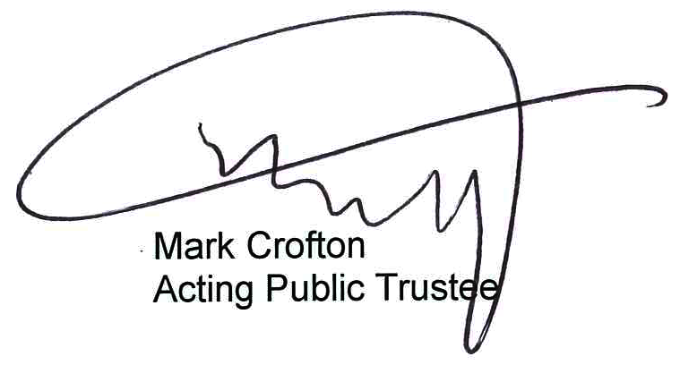
I would like to take this opportunity to acknowledge and thank our dedicated staff who have worked tirelessly over the past year to provide the services that this organisation delivers. The efforts of all staff will continue to ensure that all Queenslanders are supported to live in a safe and caring community.

